Gopi Saravanamuthu

Responsive website

## Html basic text and heading.

## Html List (order list, un order list.)

## Html Image.

## Html Link.

## Html code structure.

## 1.Html basic text and heading

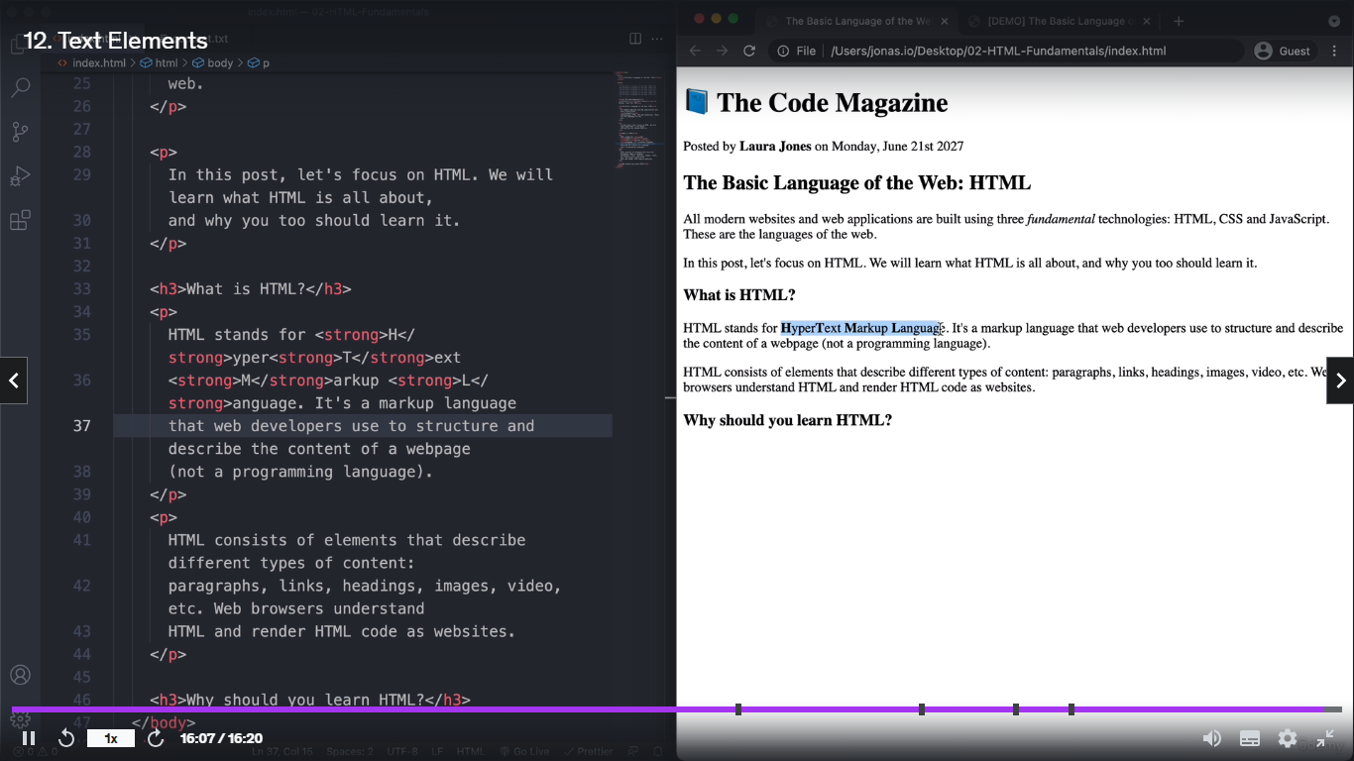

## 2.Html List (order list, un order list.)

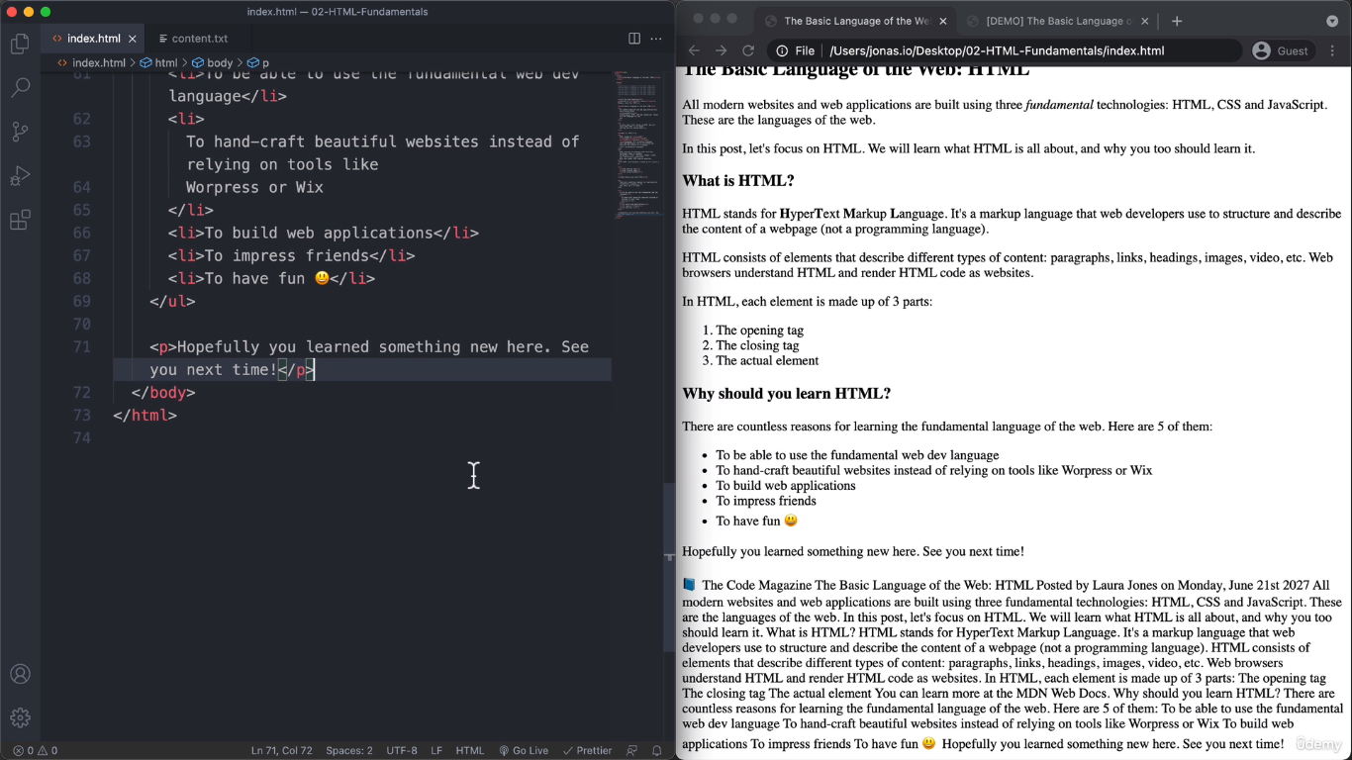

<ol> order list 1,2,3

<ul>unorder list …..

## 3.Html Image

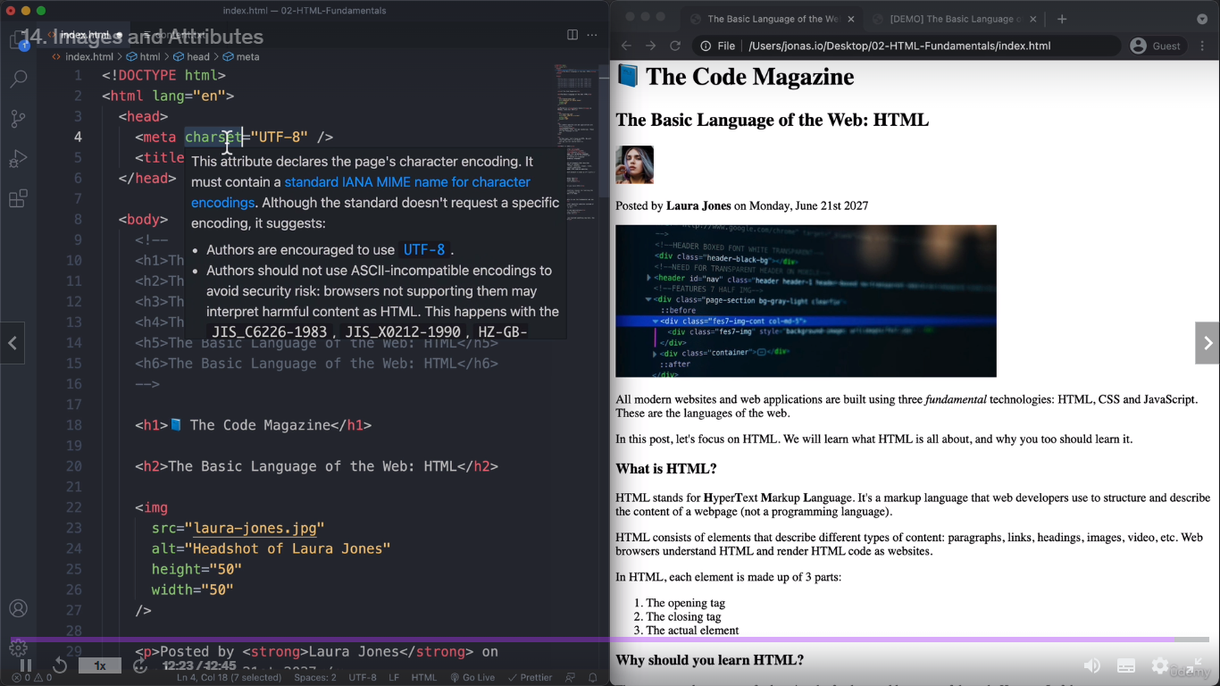

## 4.Html Link.

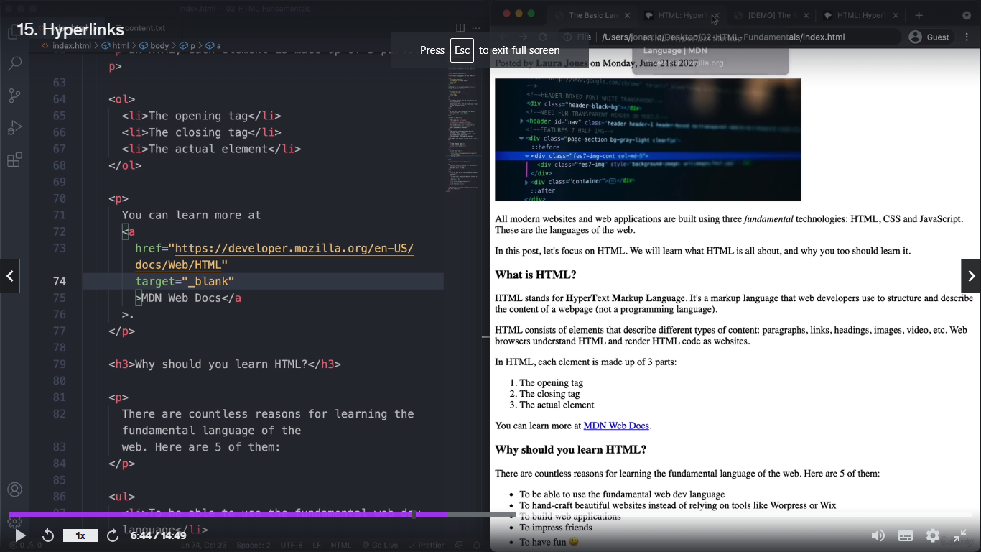

1. If we enter one link it will navigate another tab (target = ”_blank”)

## 5.Html Code structure.

<header>

<nav><li></li><nav>

<header>

<article> <header><h1></h1> <img><header><article>

<aside><h></h></aside> -- this using for secondary information

<footer>copyright &copy</footer> --- this &copy give the copy right simple.

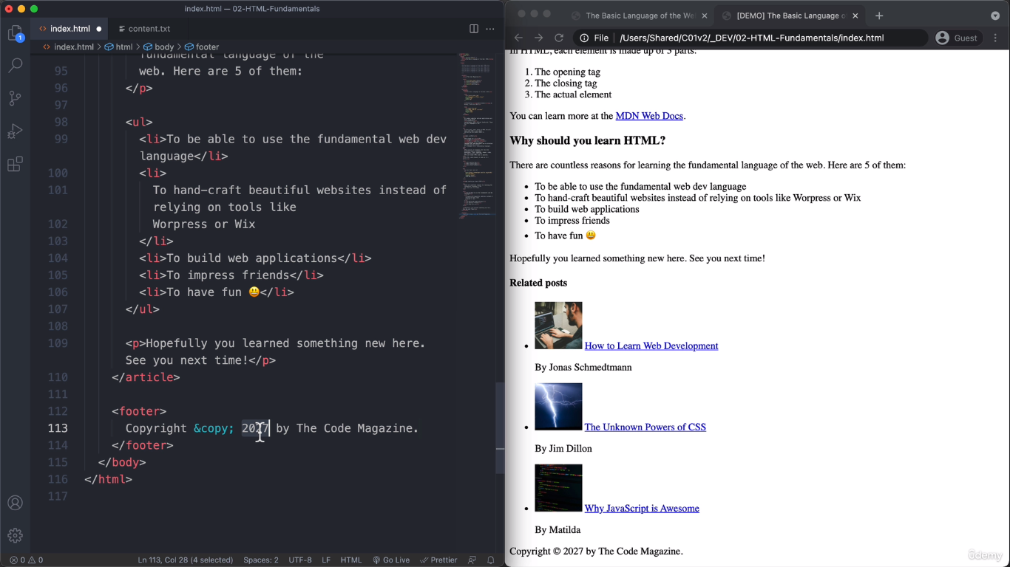

Normal arrow and simple la we don’t add icon level once enter key level pls refer coding heroes web site

**Css**

## CSS Text Related.

## CSS Colours.

## CSS pseudocode.

## CSS padding, margin.

## CSS content screen centre alignment .

## CSS position.

## 1.CSS Text Related.

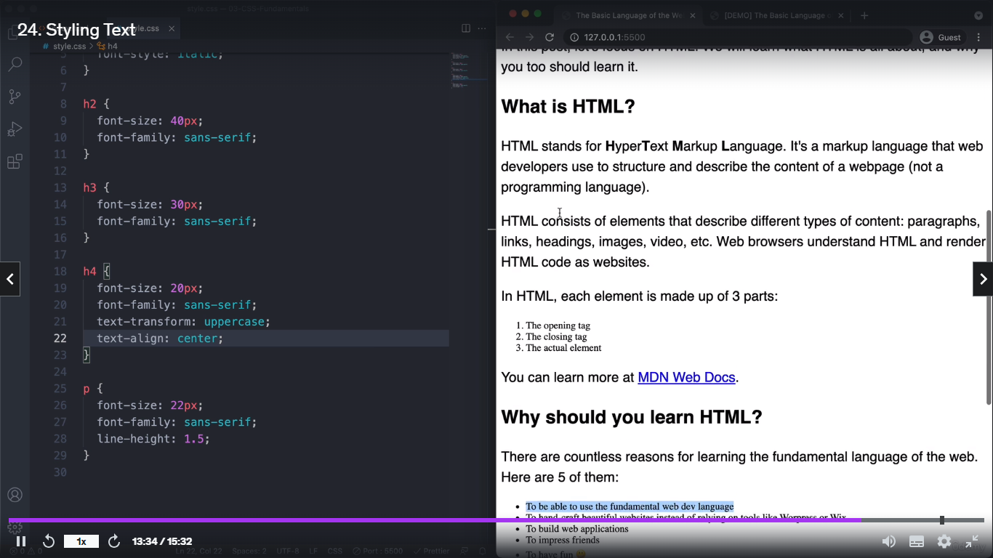

Line height -> one content to another content line cap

List la bullet point or number hide -> list-style: none;

We can write id in html element then access the that element in CSS part like-> #element name{}

## 2.CSS Colour.

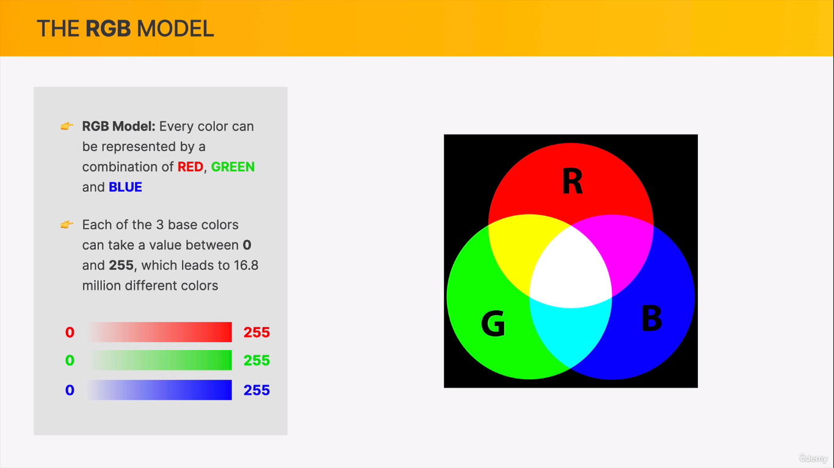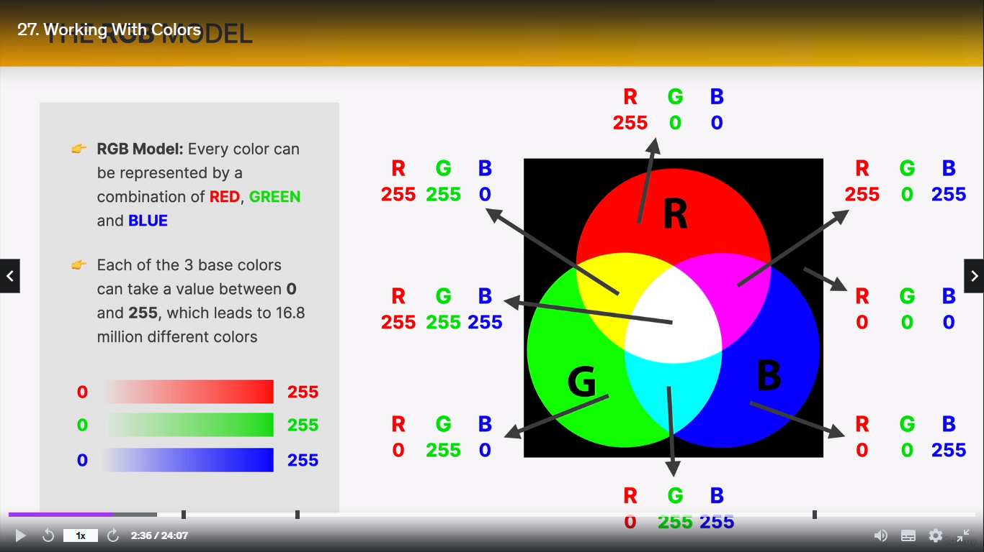

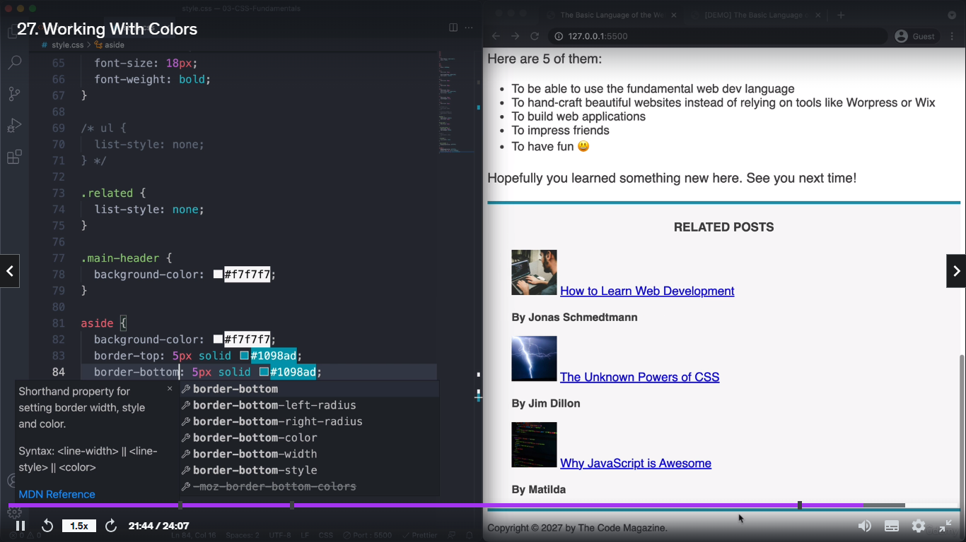

Top and bottom colour border

## 3.CSS pseudocode.

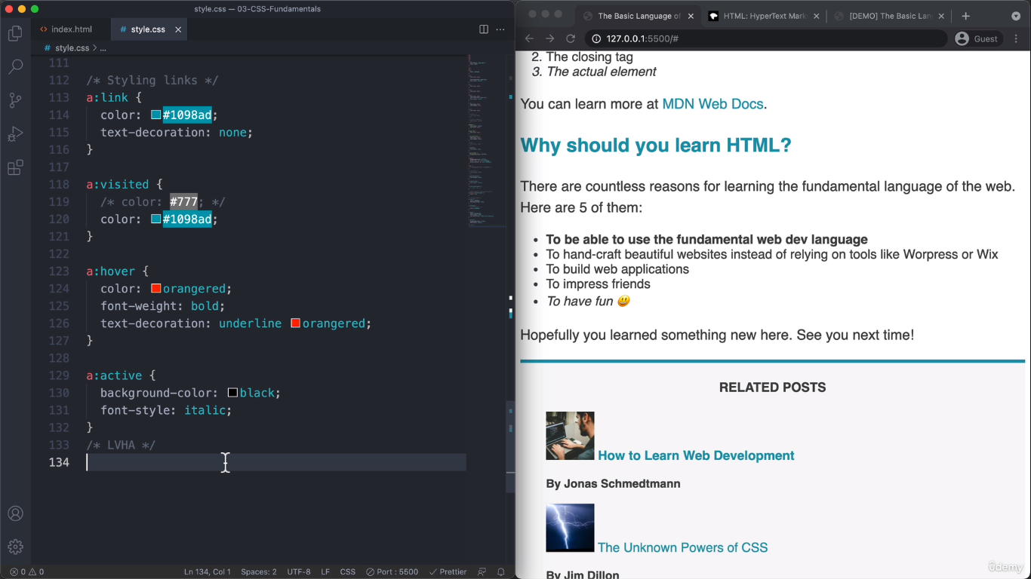

a: link -> this will use for only link attribute then hide the underline.

a: active-> this will use for when we click the link that time it will be changed some action like as we enter above the code

## 5. CSS padding, margin.

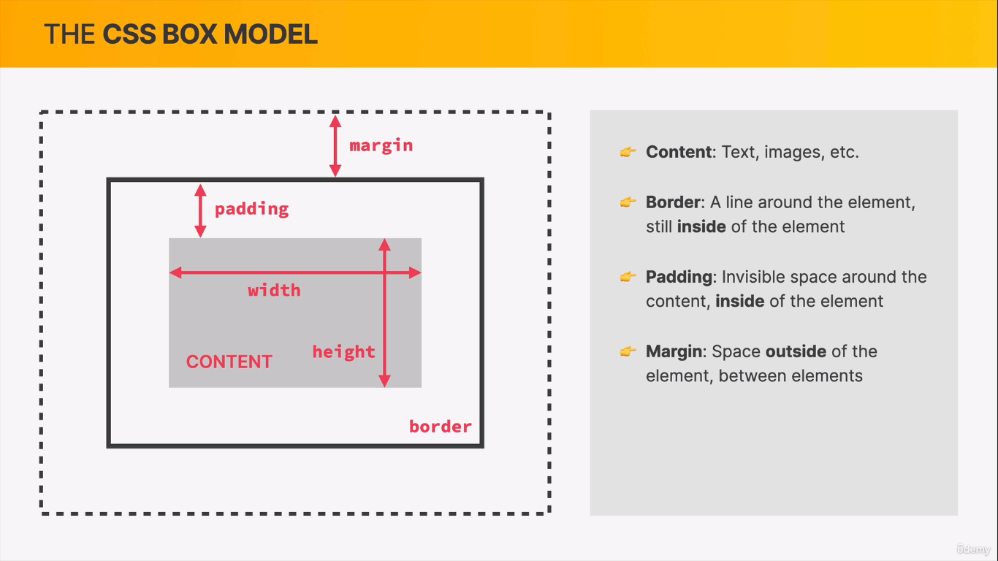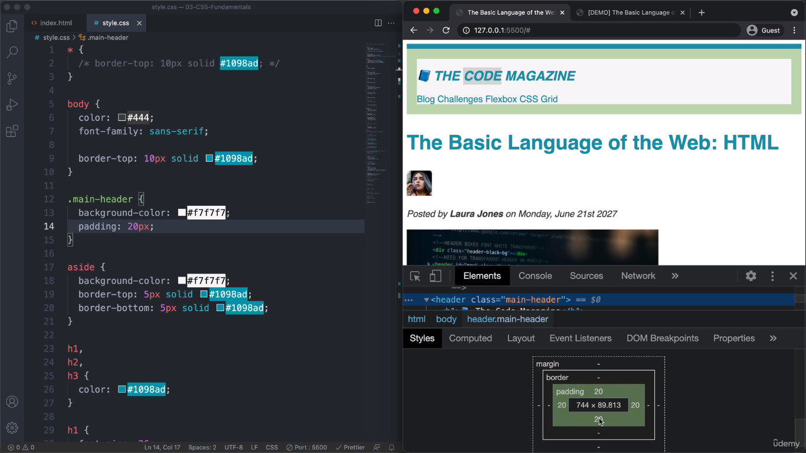

Padding – it will access for inside the border.

Margin- it will access for out side the border.

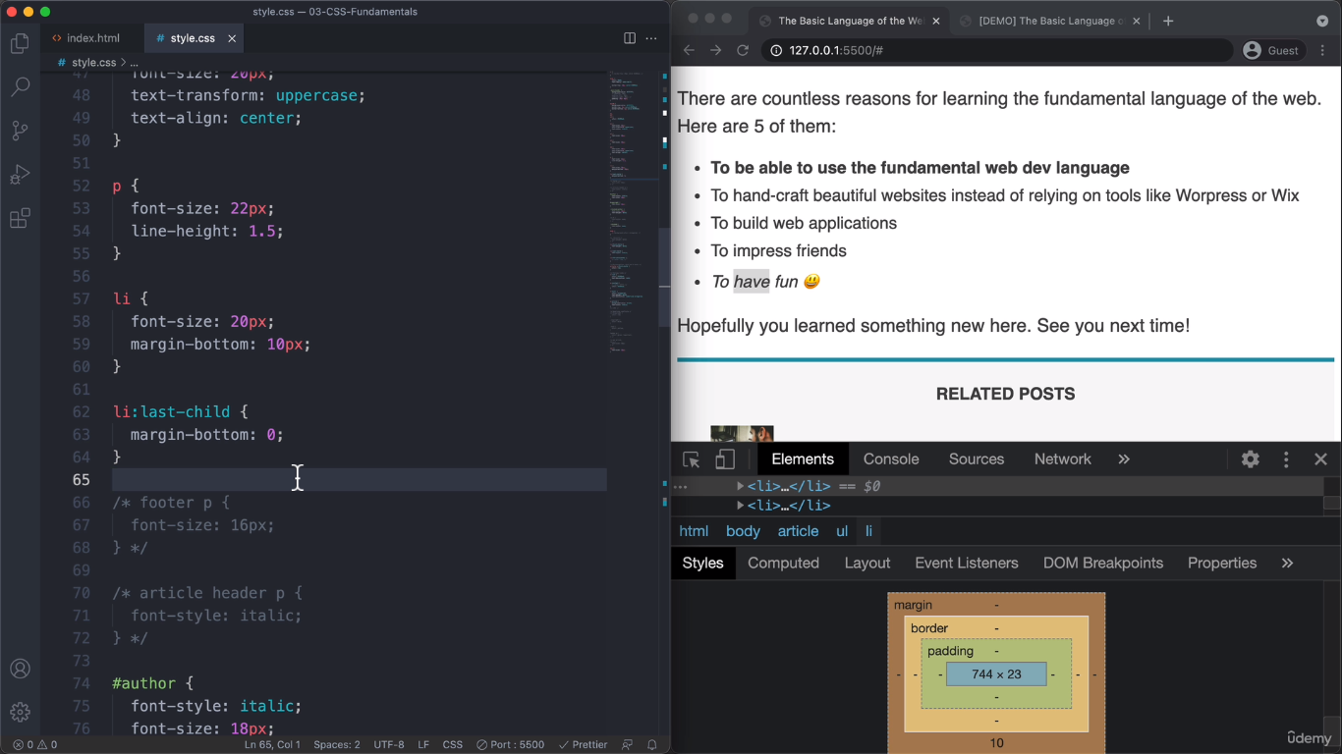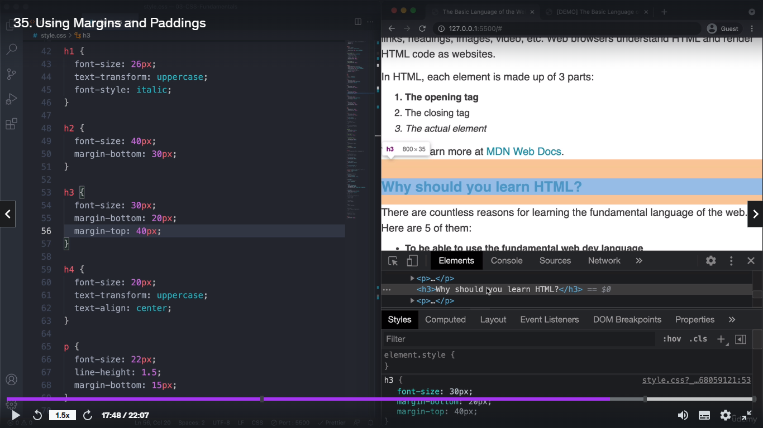

Width 100% - eppo namba screena kami ,athgam scroll pannalum antha screen ku eatha maari size correcta irukkum ithu responsive website ku use aagum.

Height- auto ethukkuna antha screenku eatha maari automatica eduthukkum height apdi illana nambo html kuduthurunthomna antha height eduthukkum

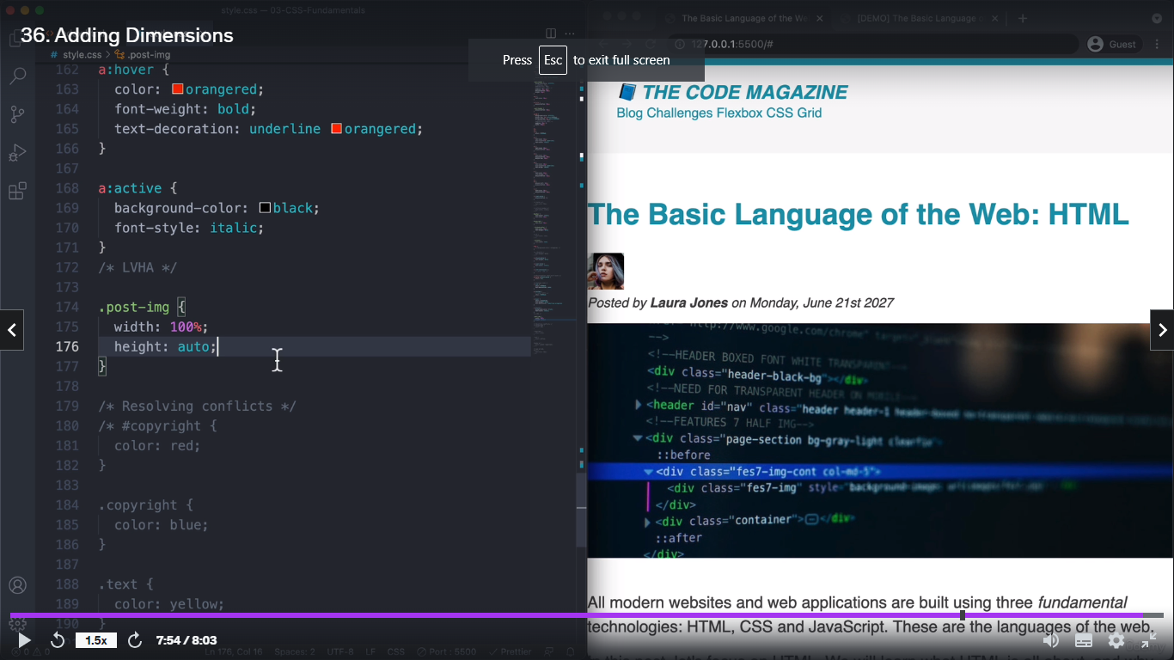

6.CSS content screen centre alignment .

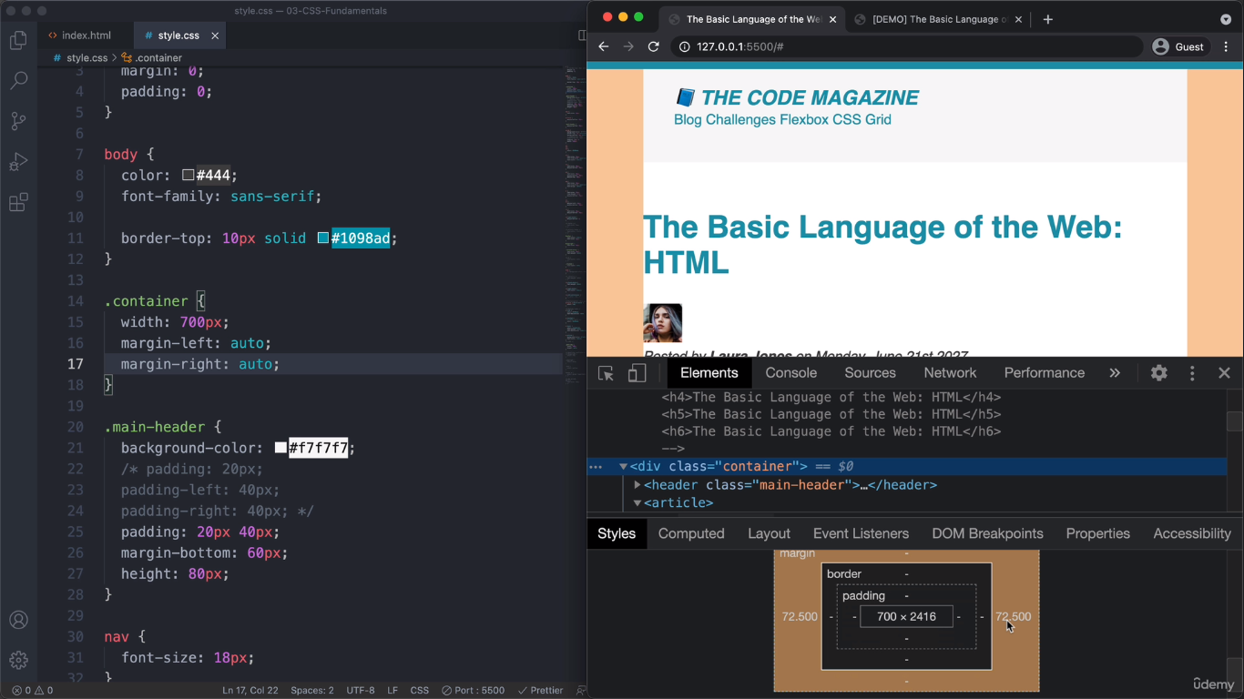

Html- container class pottu antha class css la R/L margin auto kudutha screen max min pannalm screen csnter la content irukkum .

## 7.CSS position.

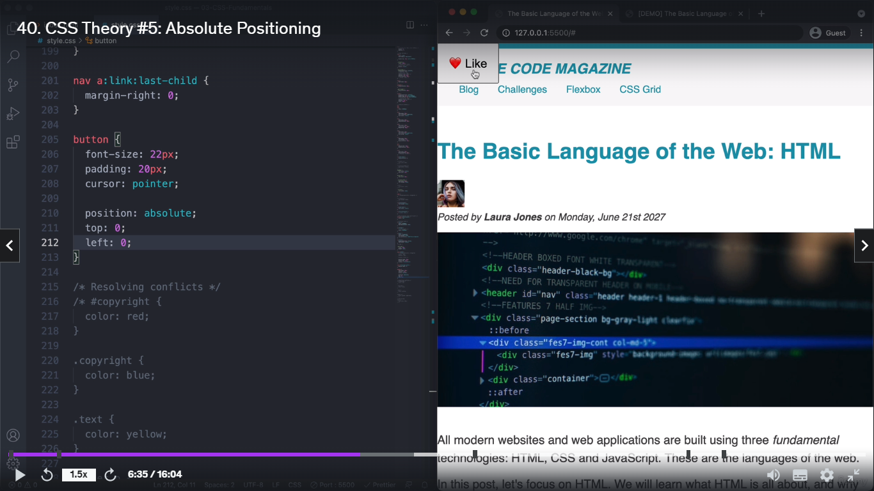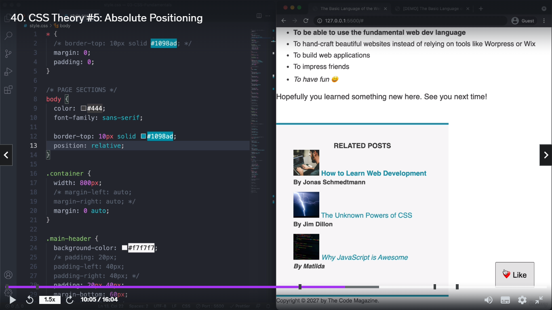

Position : relative na statica irukkum engayum change aagathu normala tha irukkum .

Position : absolute na engavenalum namba kudukkura desigh setb pannikklam .

Ex: <div class=”reni”>

<button class=gopi ><button>

</div>

Ippo parant reni component kullatha button gopi irukku so gopi chile reni parant

Css la :

Parant reni relative kuduthu child gopi ku absolte kudutha.

Renilarunthutha nambo absolte evlo kuduthomo work aagum .

Athe reniku relative set pannalana antha absolute enga venumnalum plac aagikkum

Simple : reni :relative na athularunthu athukullve absolute calculate panni place aagikkum .

Apdi illana overall enga venalum place aagikkum.

Ippo oru dive ku full color kuduthu athu oru content padding set pannomna antha dive fulllave color irukum but inline-block pottomna antha contenku eatha maari antha div color reduce aagirum

## CSS Layouts.

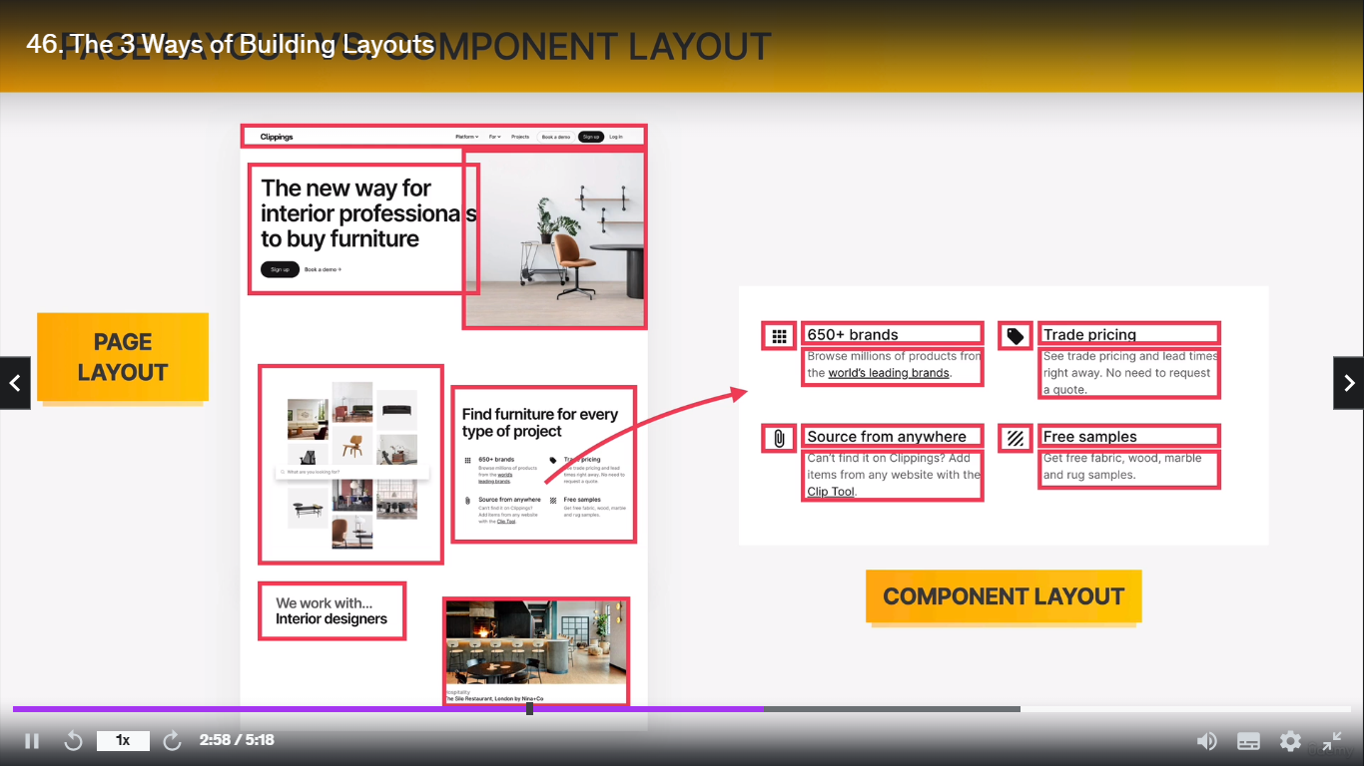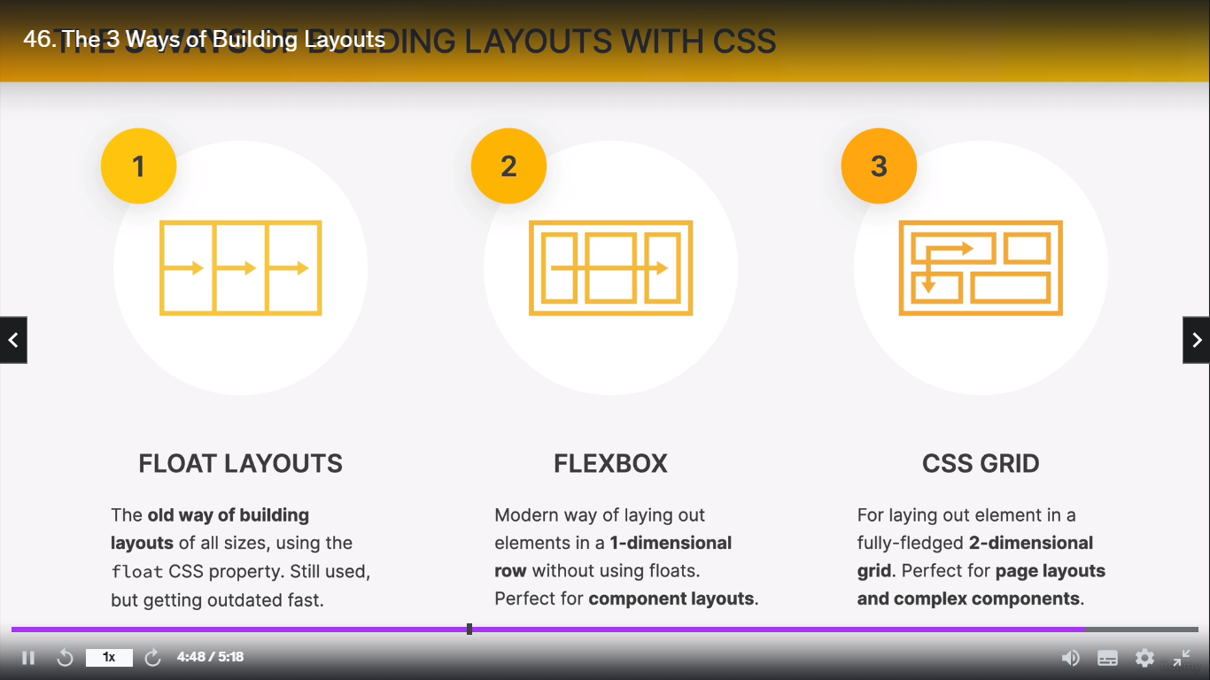

## 2.CSS Layouts nave bar header adjust mend importance

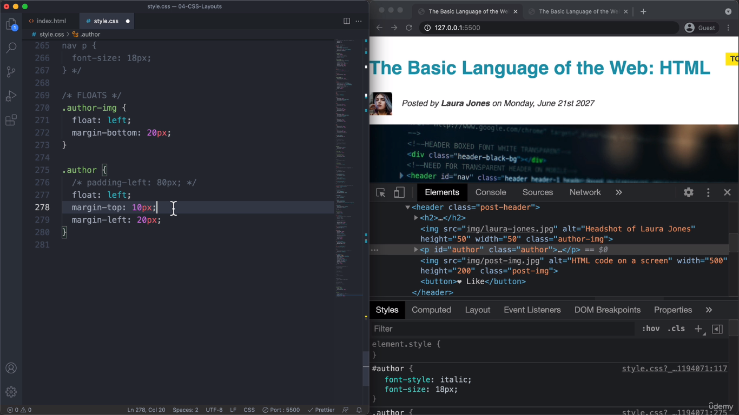

Float:

Flexbox;easiear to implement page level

Cssgrid : easier to implement component level

1-> ithu left float img leftum content leftum vachirukku img larunth left conten calculate aagirukku contenku float right potta athu correct code flow ill 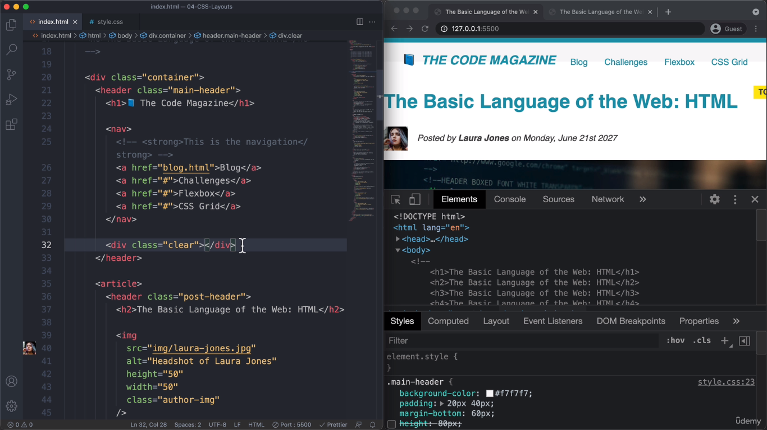

***** intha header kulla h1 and nav irukku ithu old model ippo kella onnu new athu follow pannu

H1->float :left;

Nave->float: right;

Itha csssla pottomna headerku oru height set panniruppom athukku keela konjam intha lesft and right vanthurum so colorum paathikku paathi theriyum .Atha solve pannatha extra oru div create panni anthukku oru class set panni antha claas cssla ippo left ku height kammina left illa right ku kammina right rendukkumena clear:both nu kudutha color full header varum

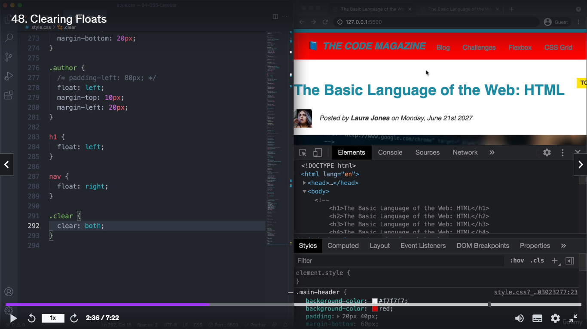

**New one :**

1. **Follow pannus**
2. **Main parant ku oru class clearfix nu atha css la pseudocode podu ::after nu { clear:both;**
3. **Content””; display:block;}**

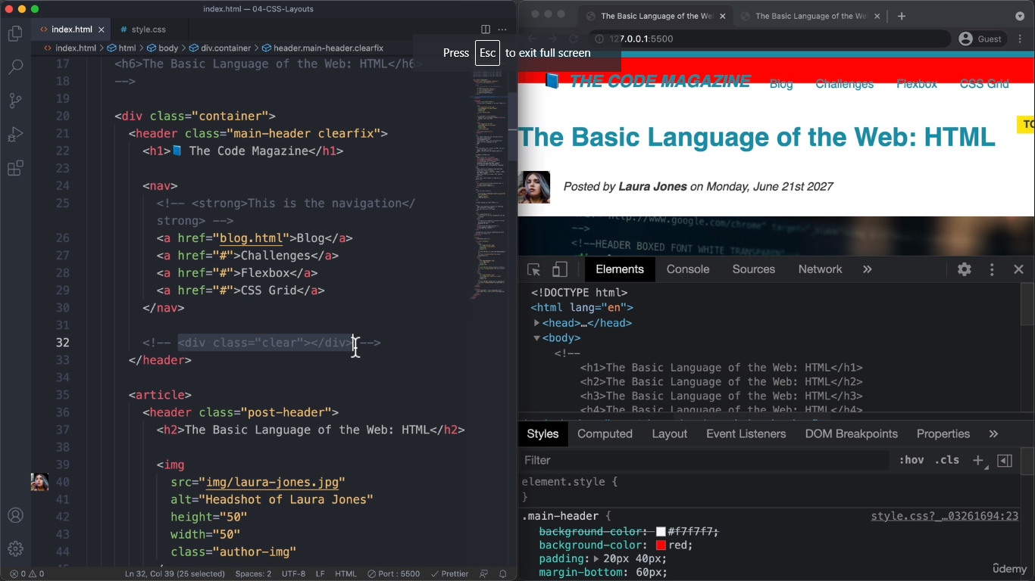

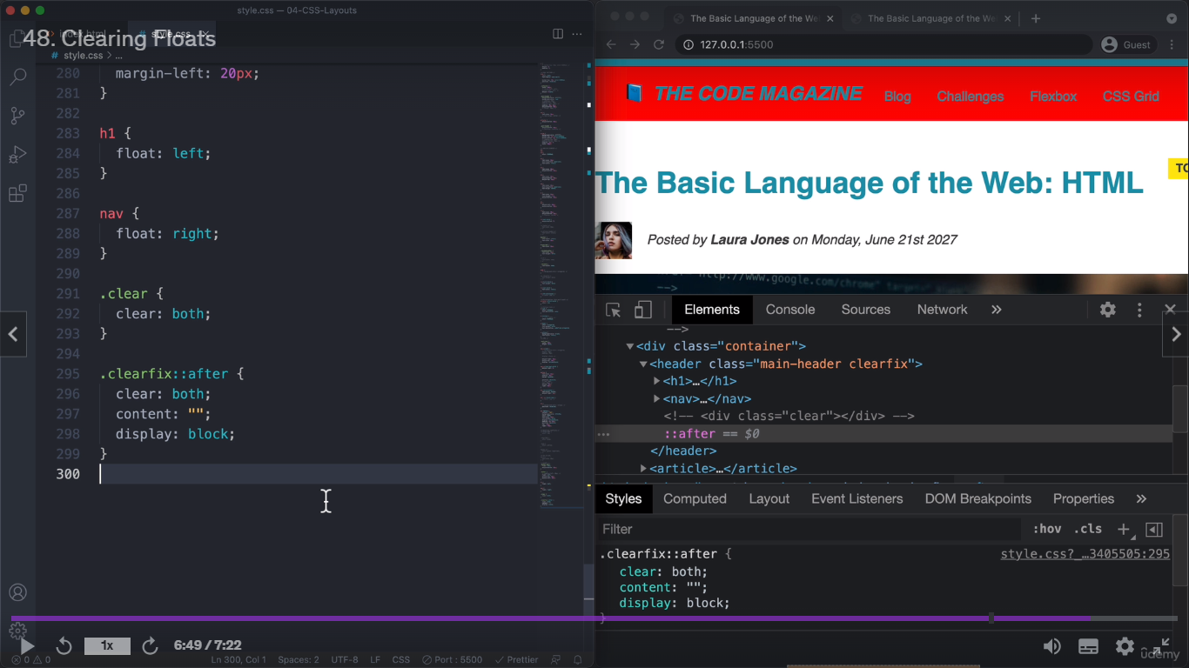

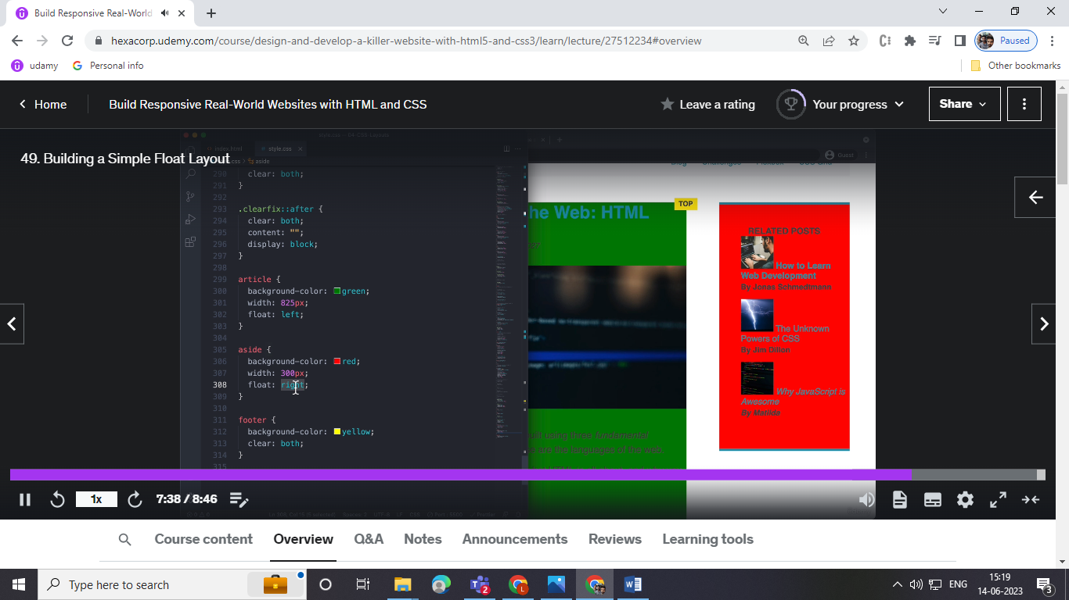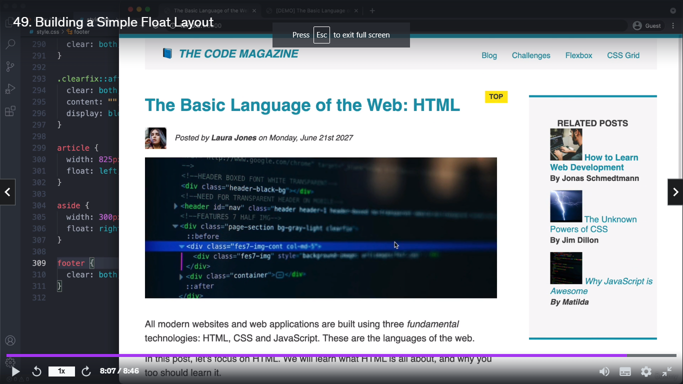

## 3.CSS FlexBox;

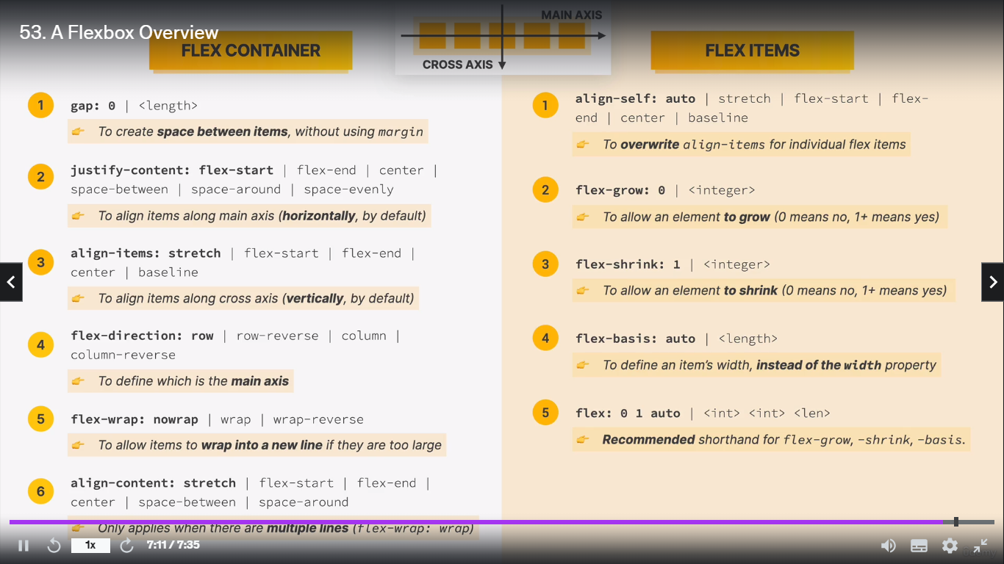

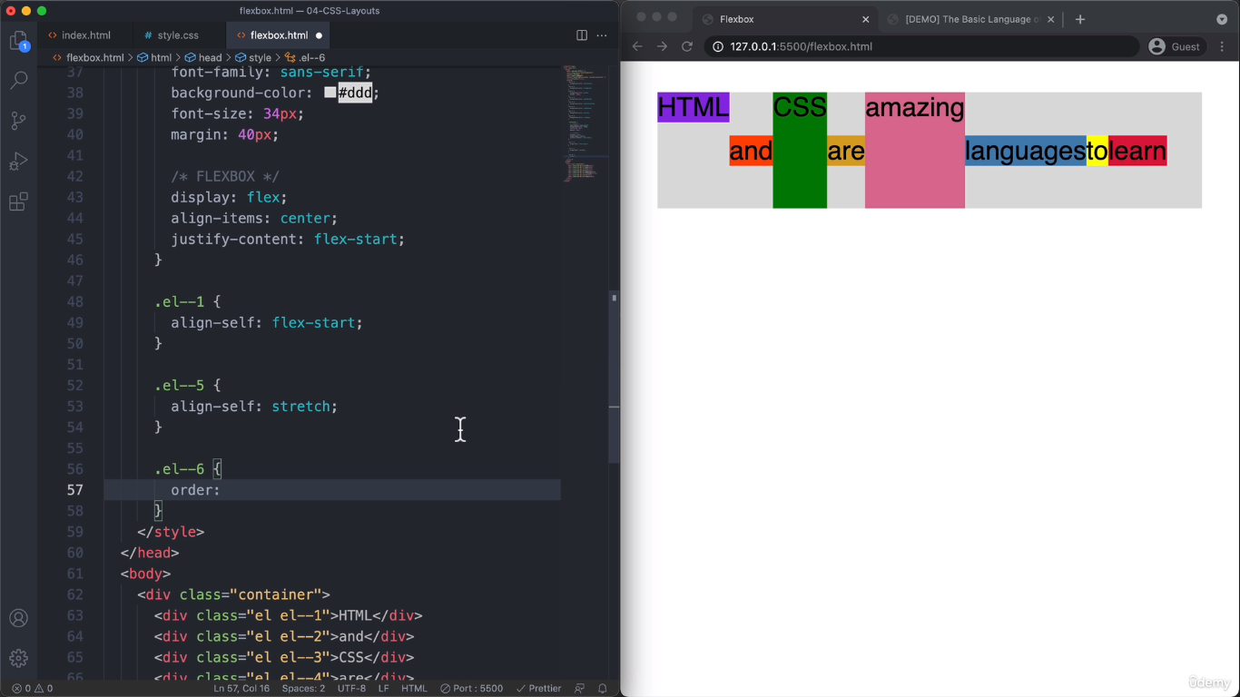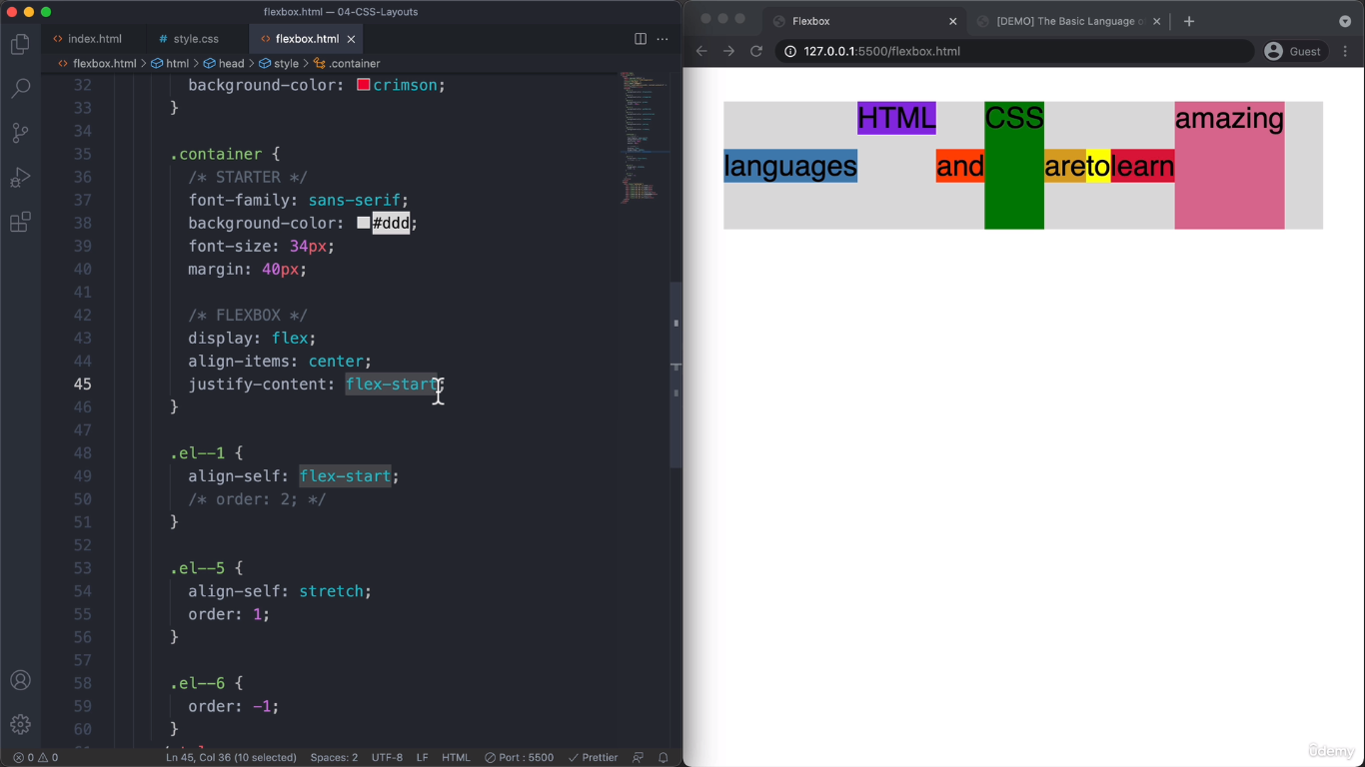

**Flex boxprogram la implement panrathu ithu full nave bar use pannalam full design use pannlam nabaloda conviniean ku eatha maari use panniklam**

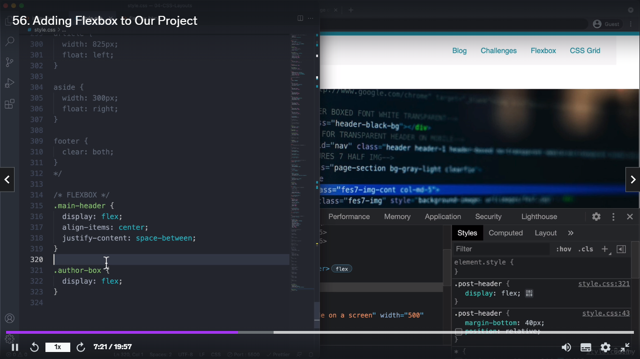

## CSS Grid.

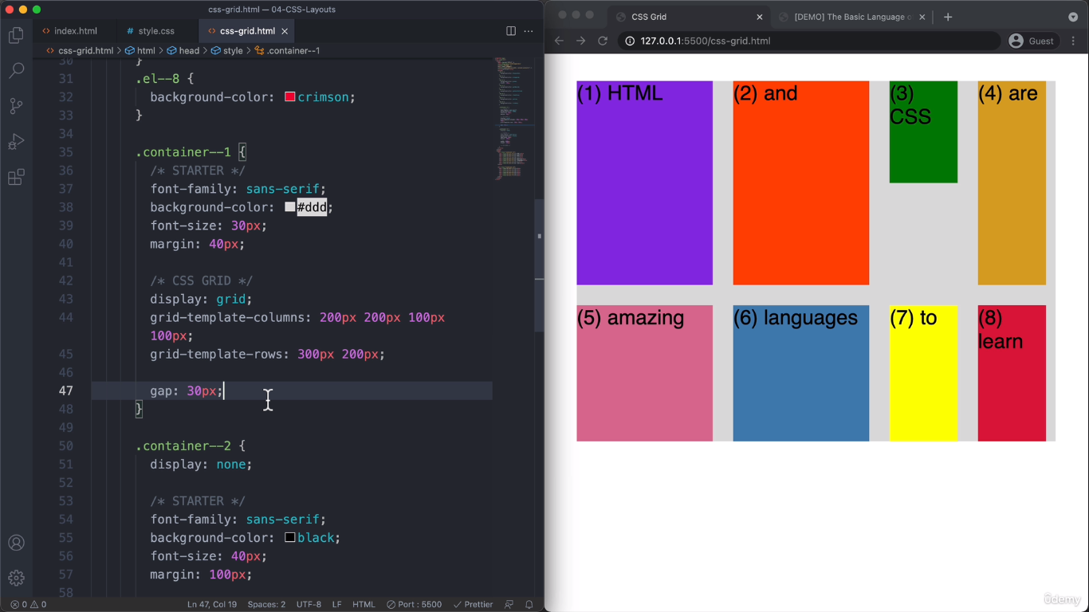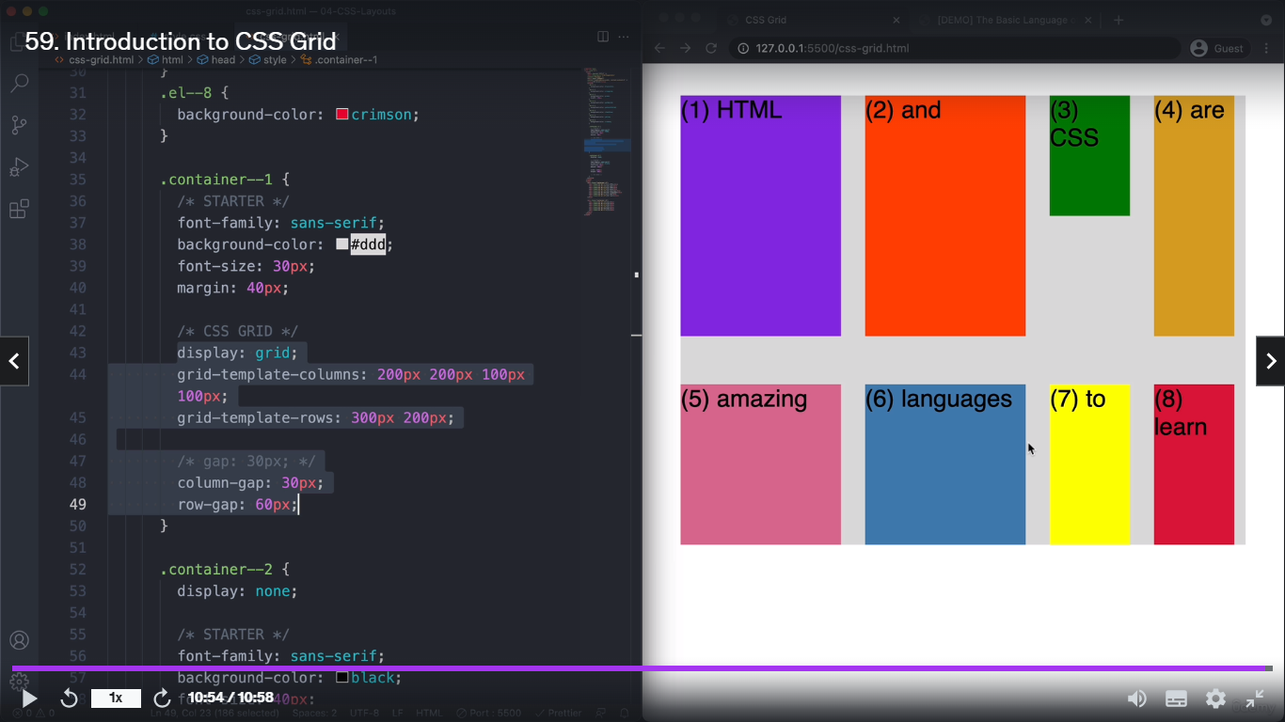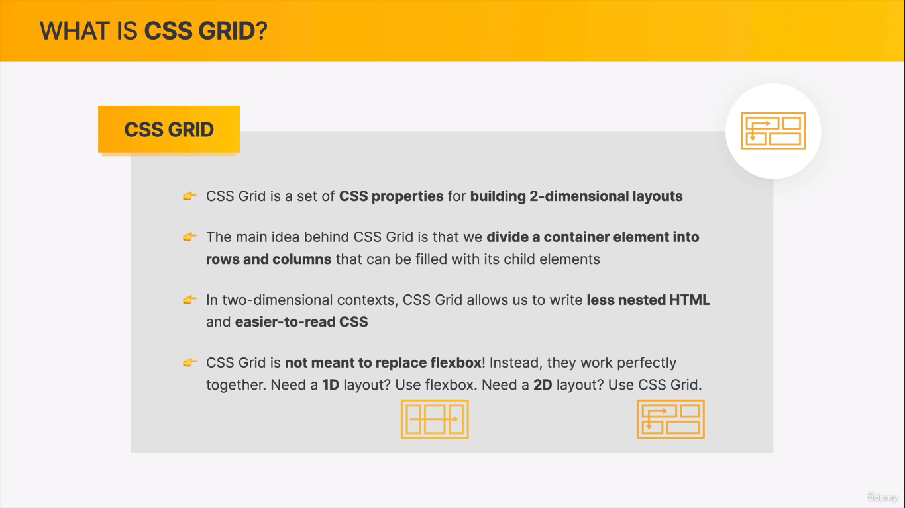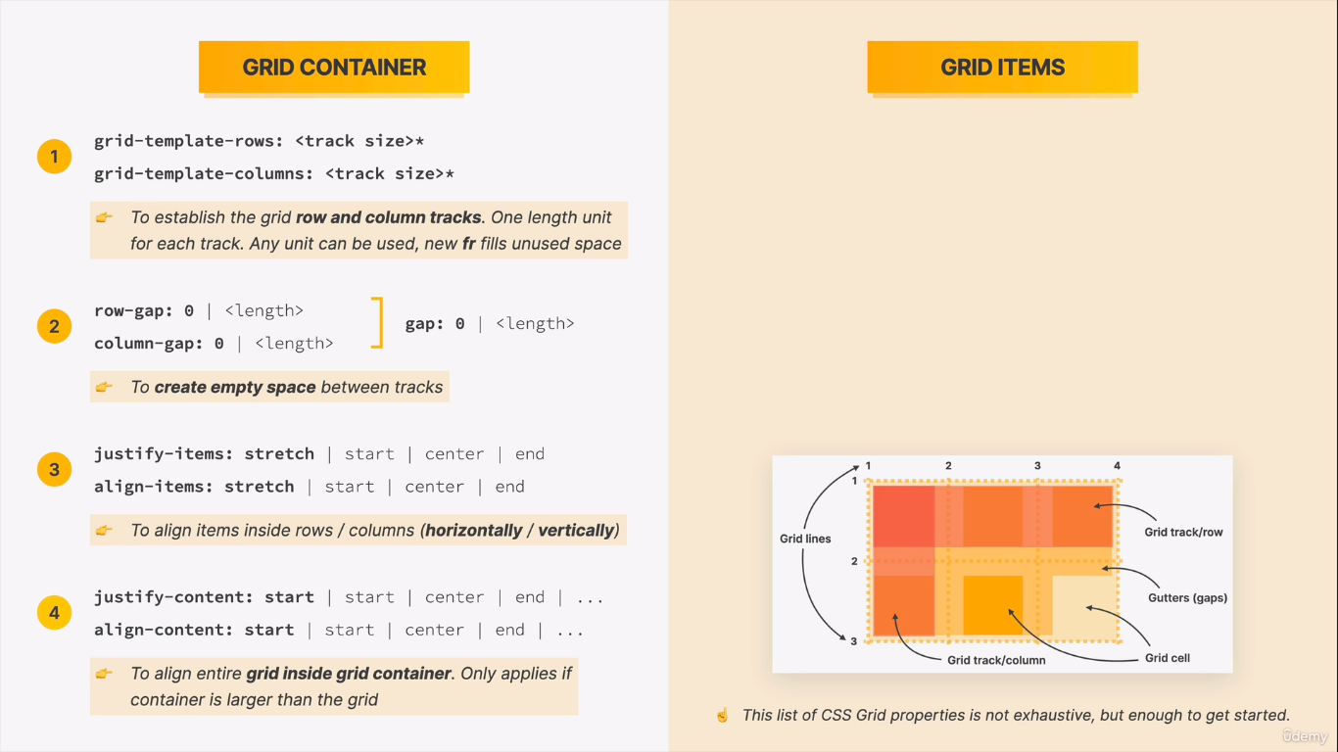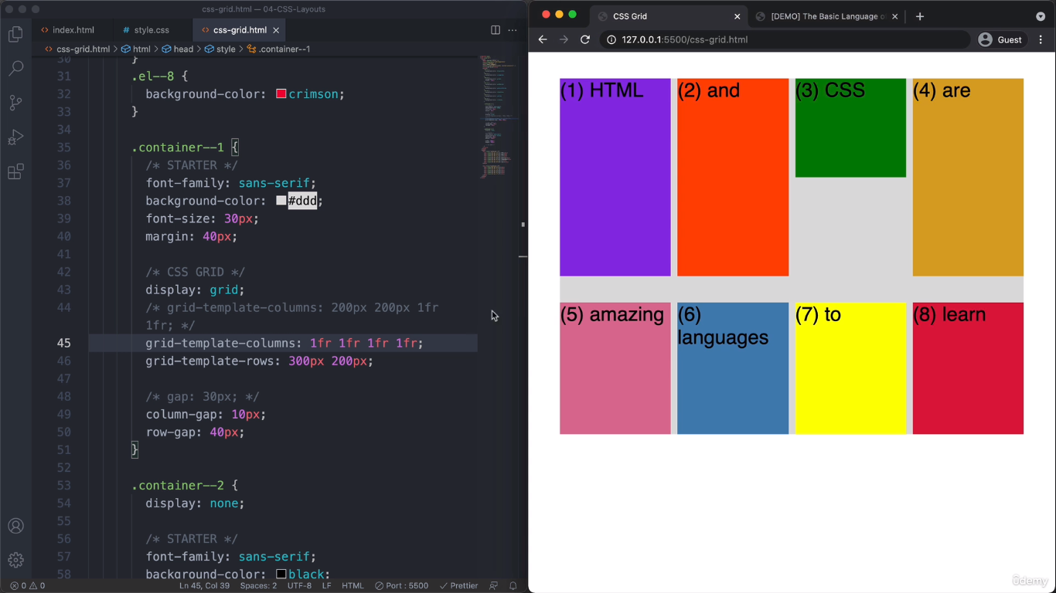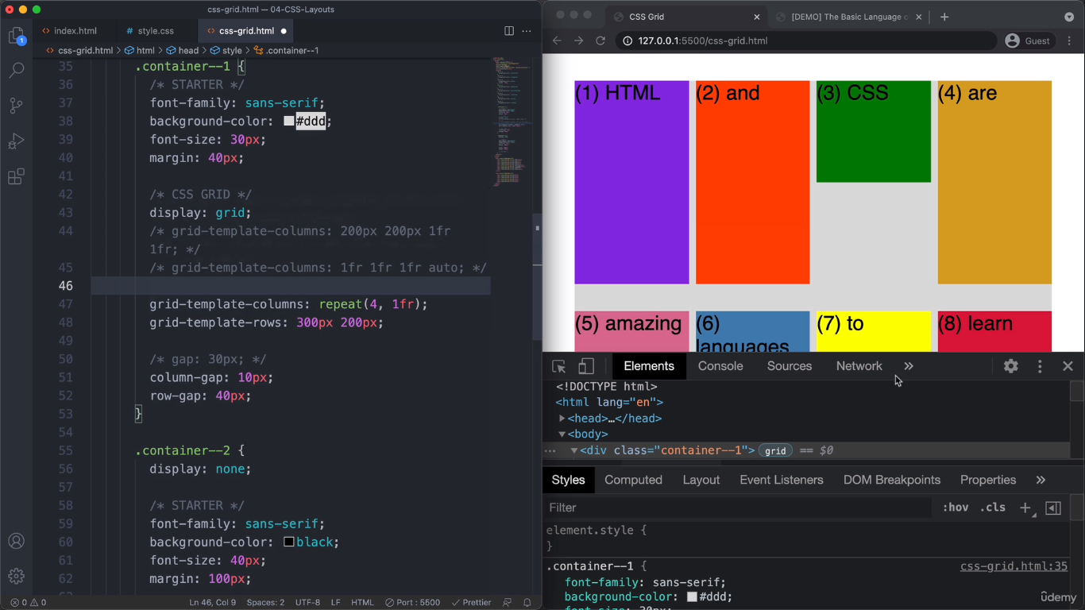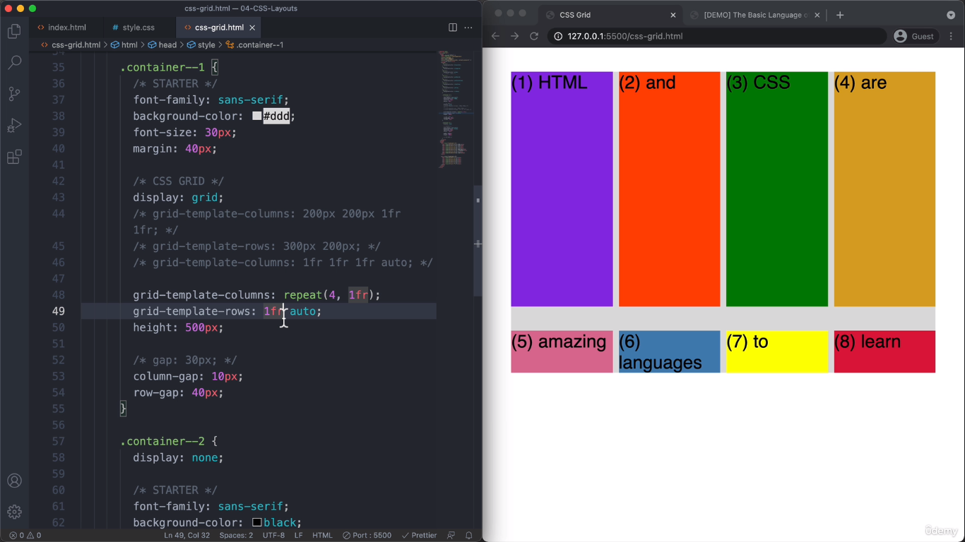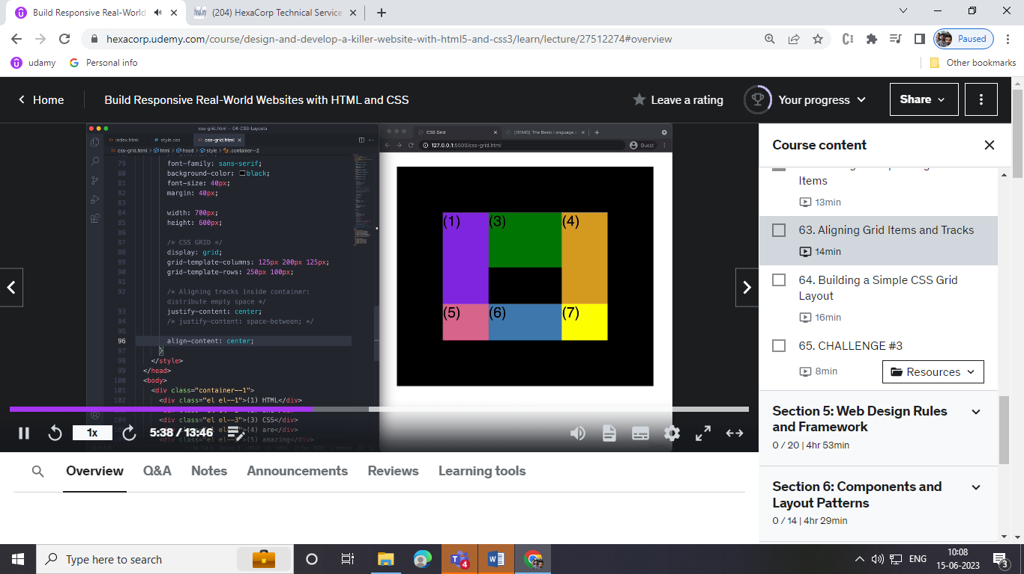

**Web design idea’s:**

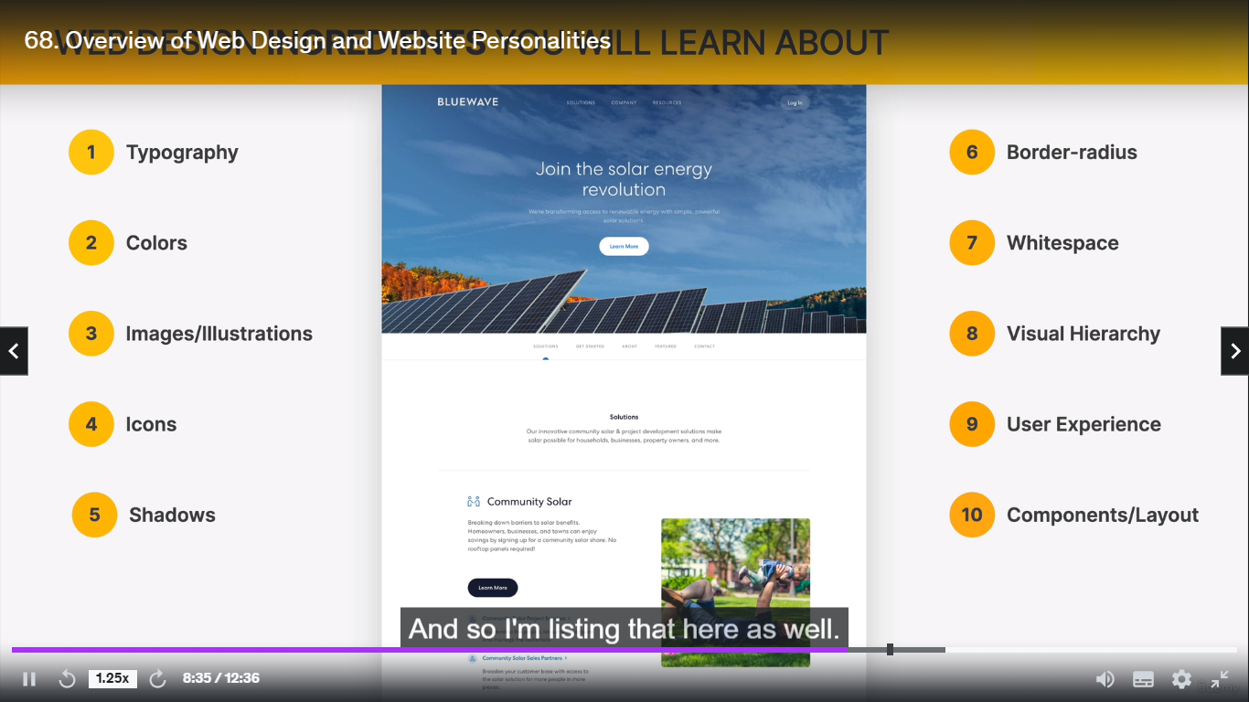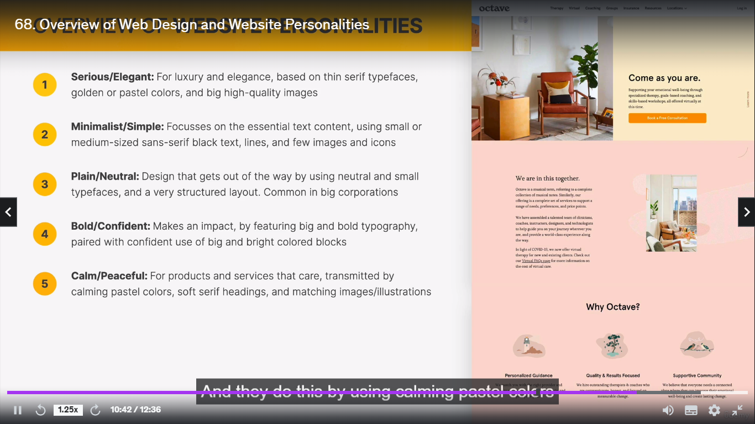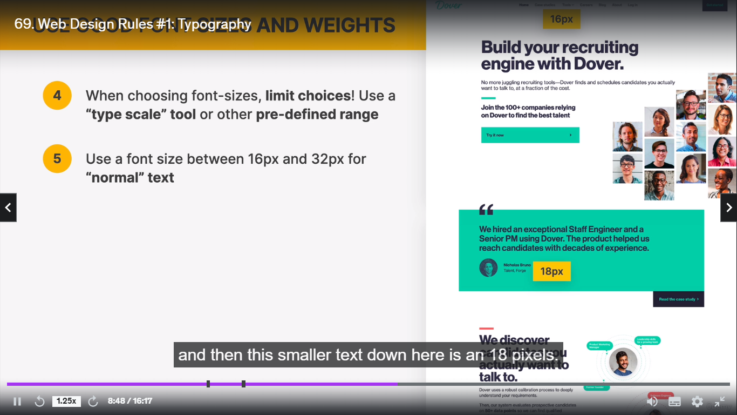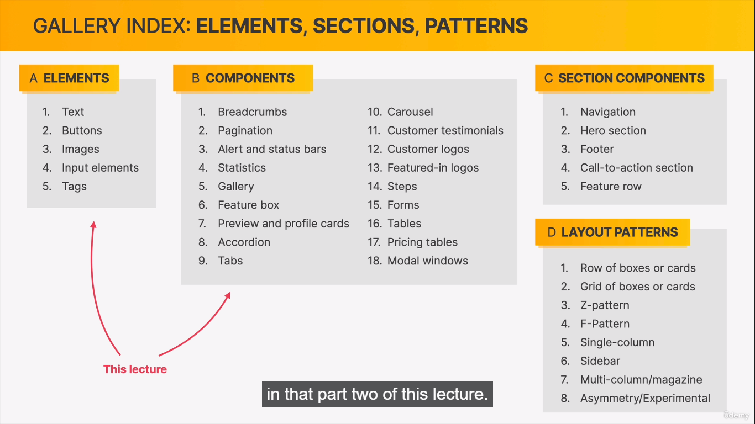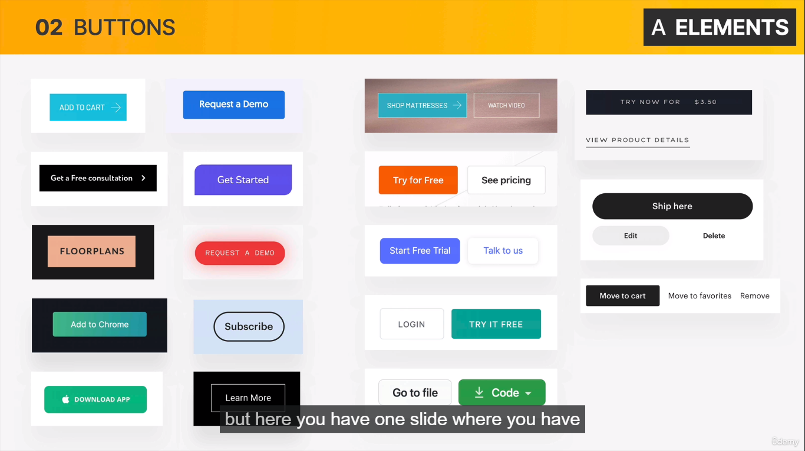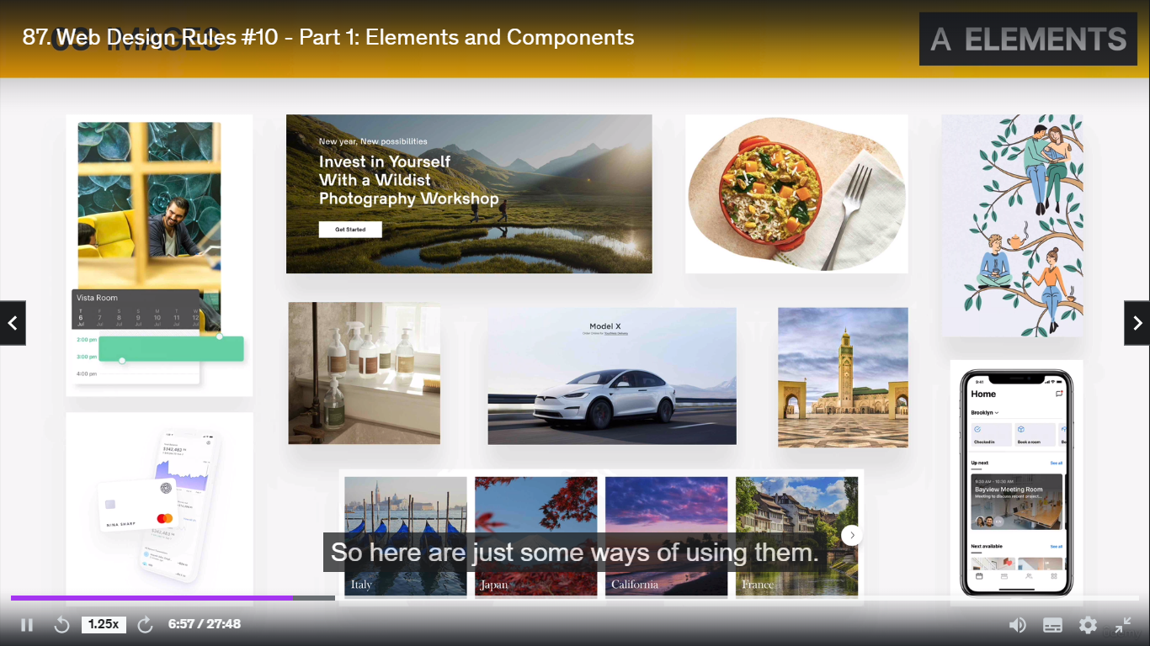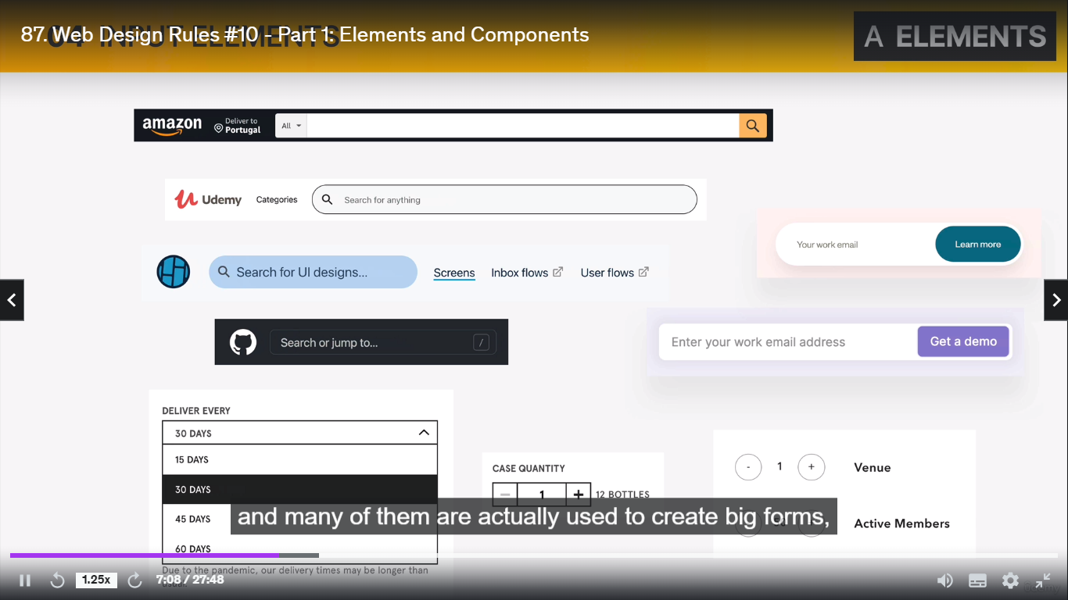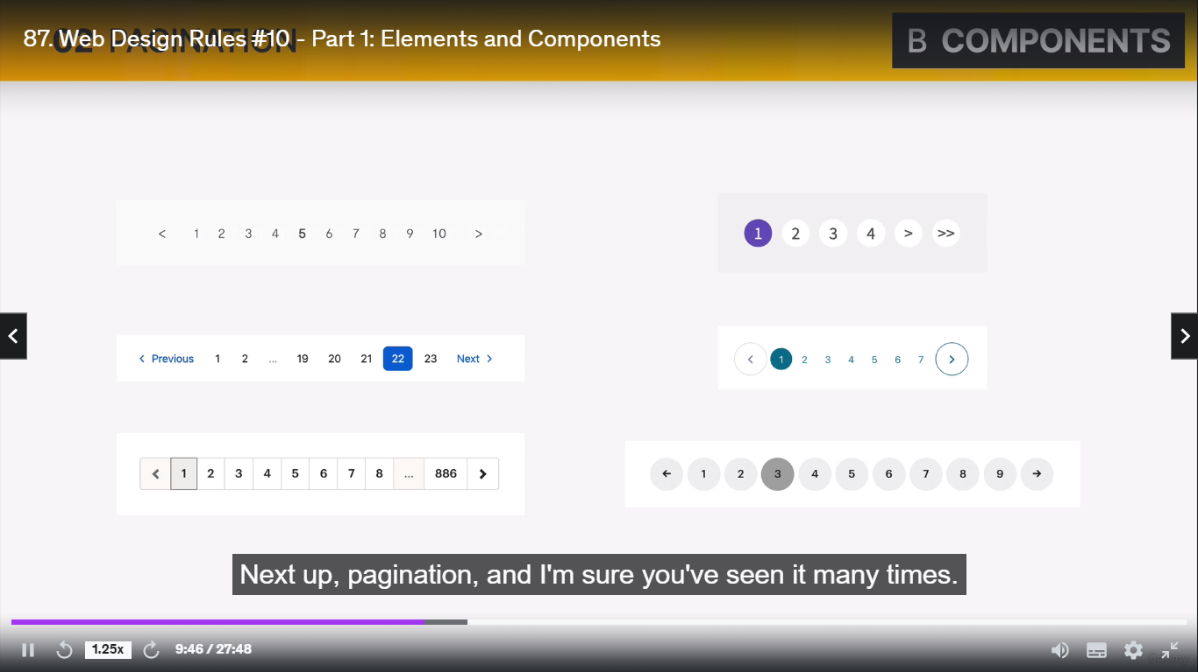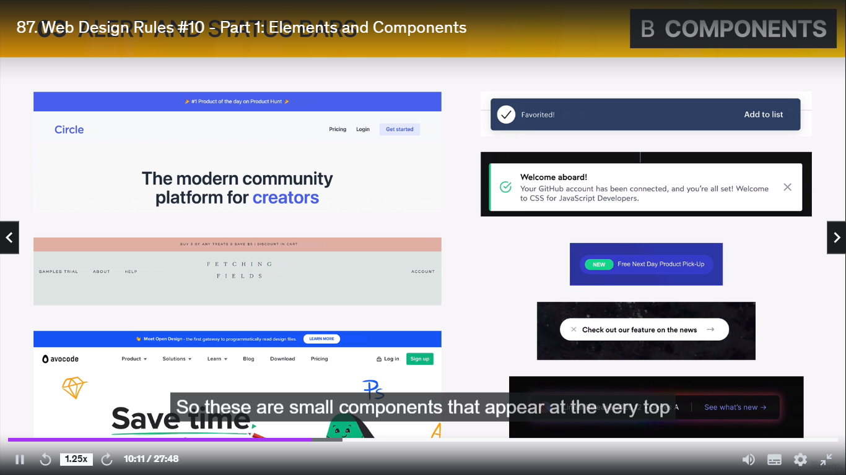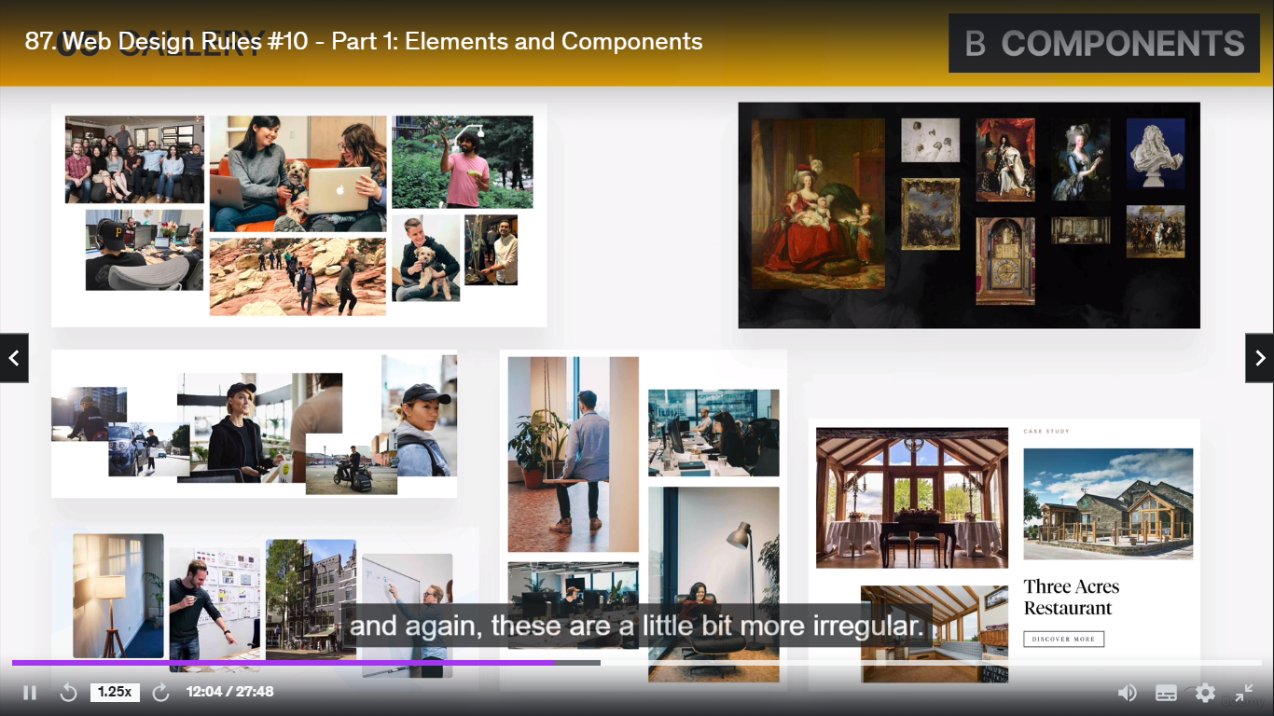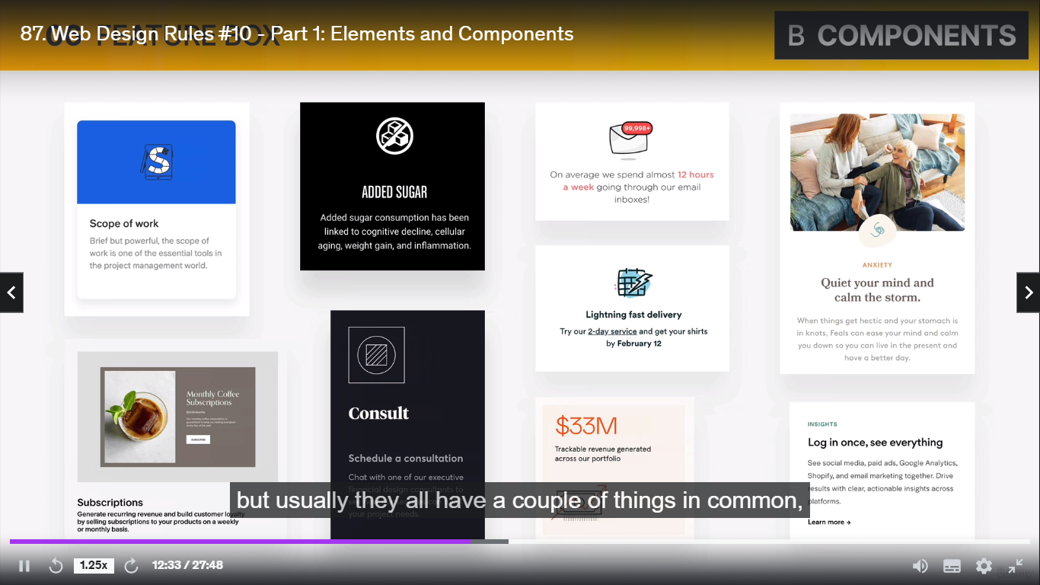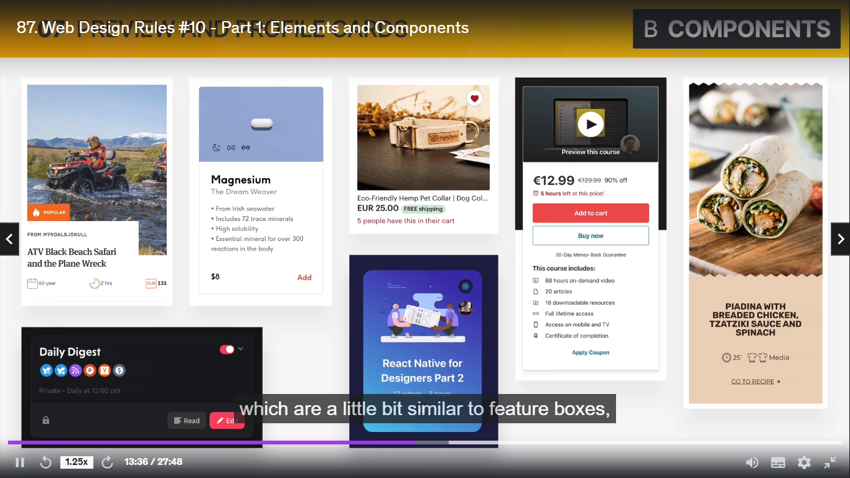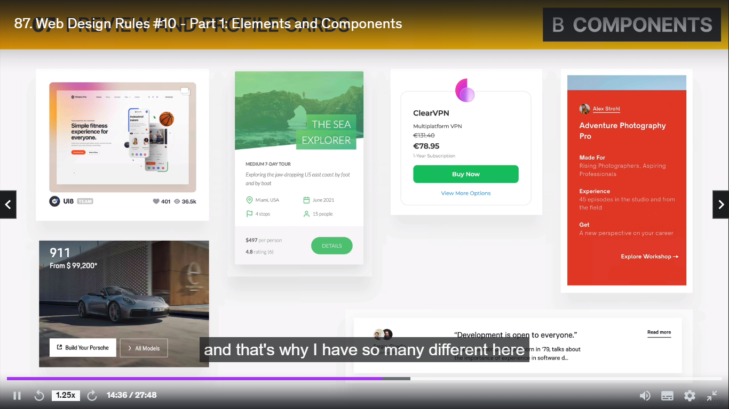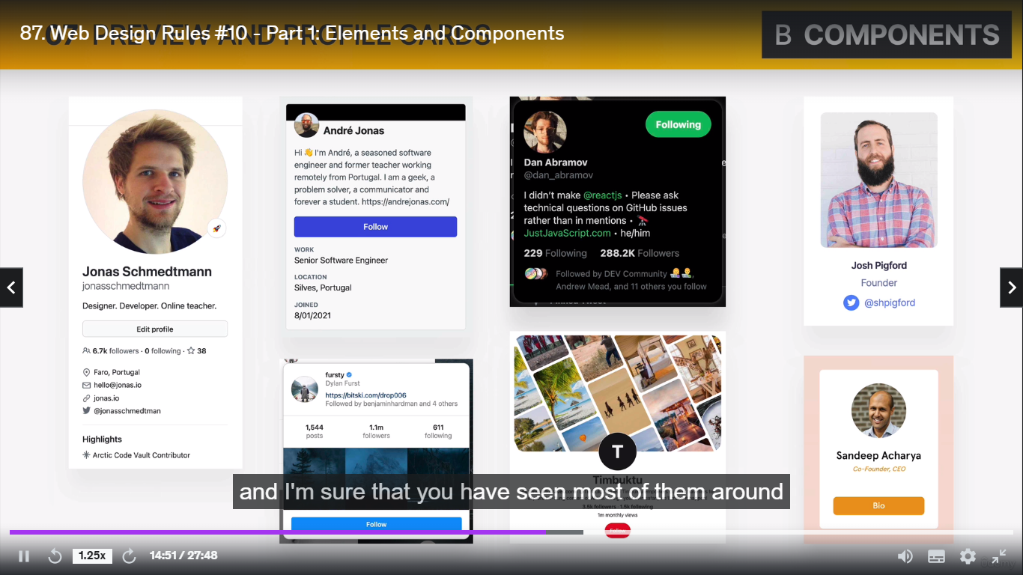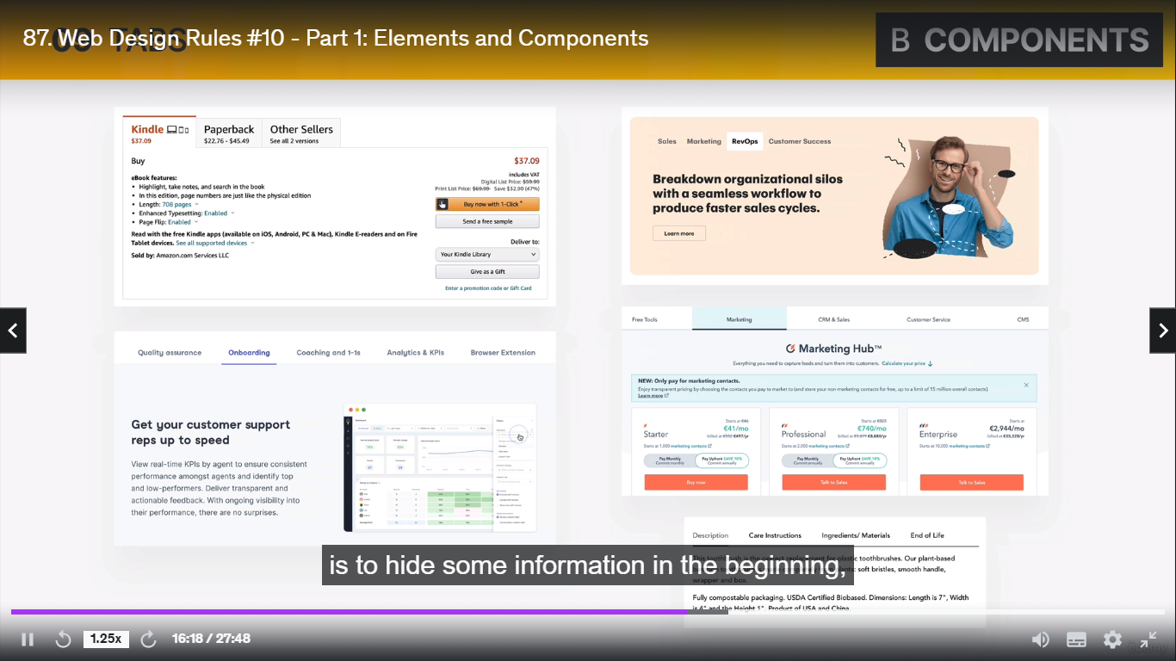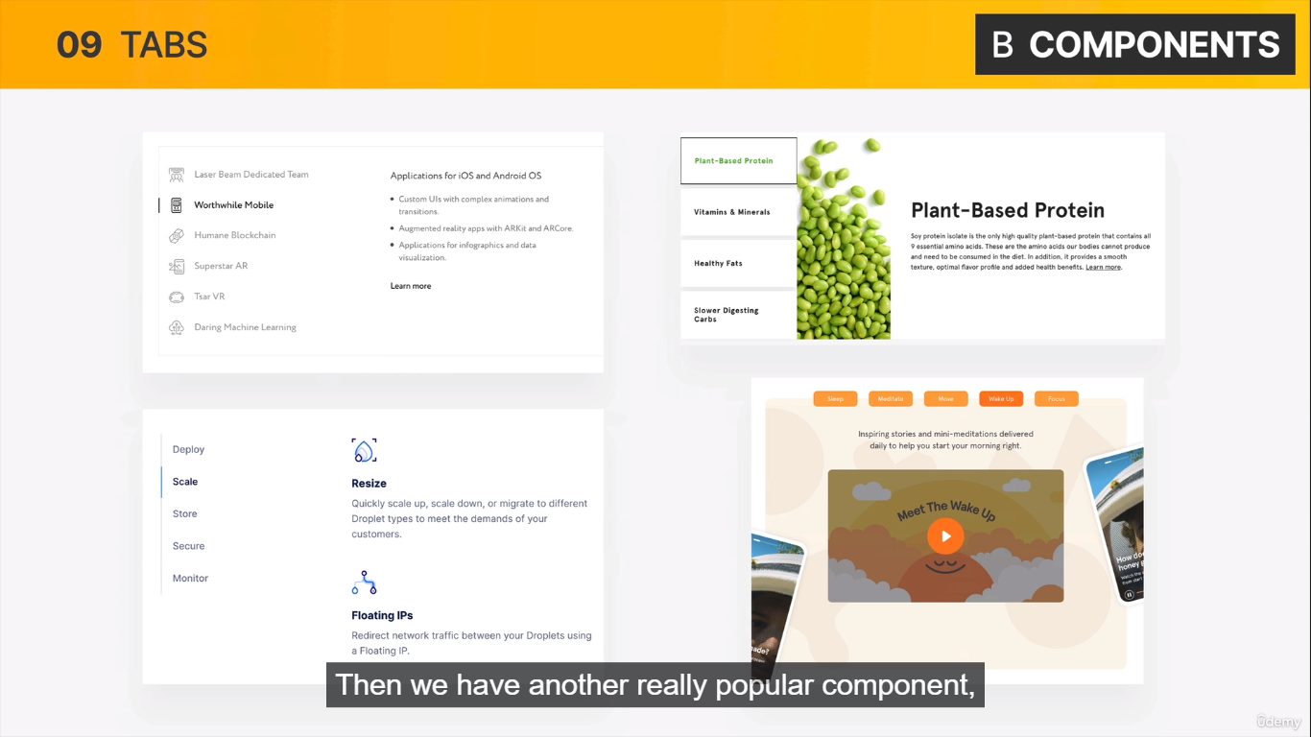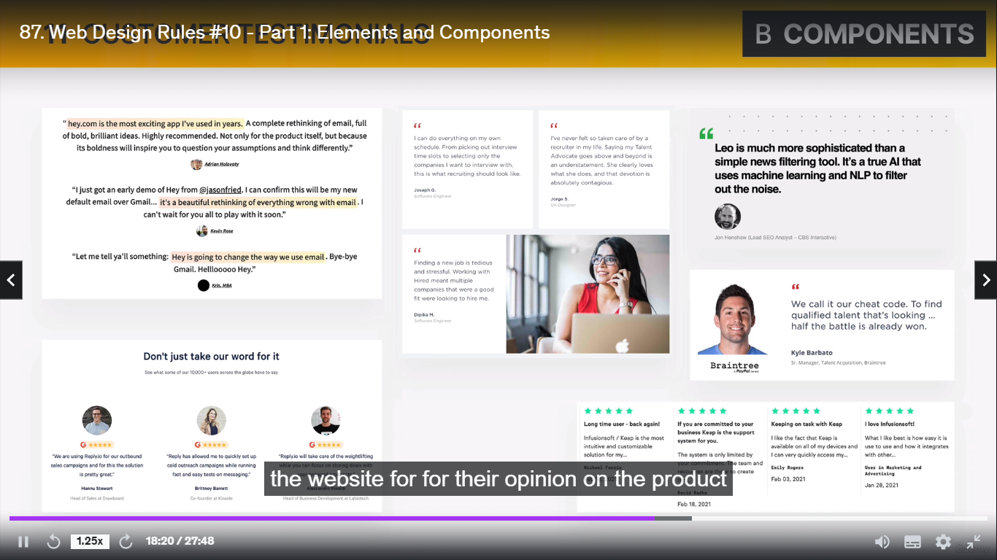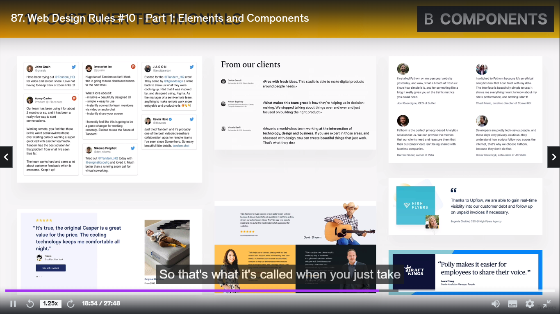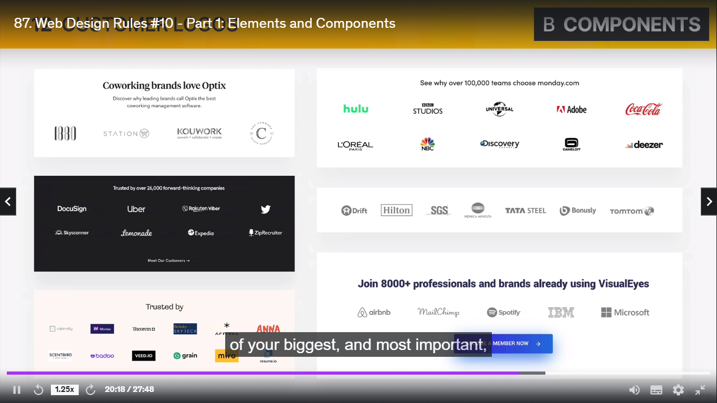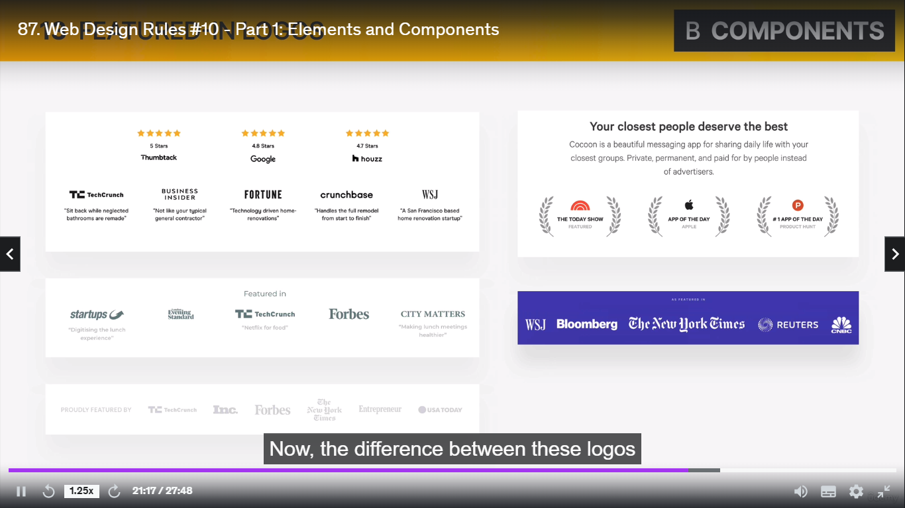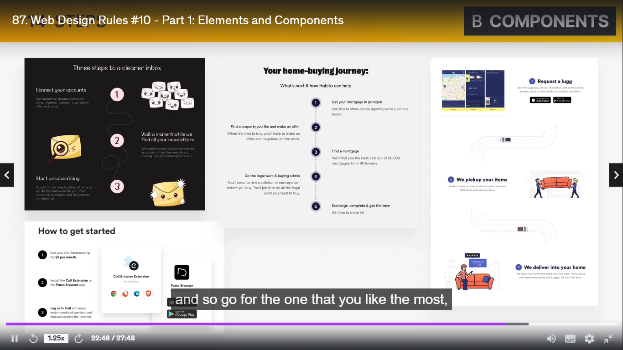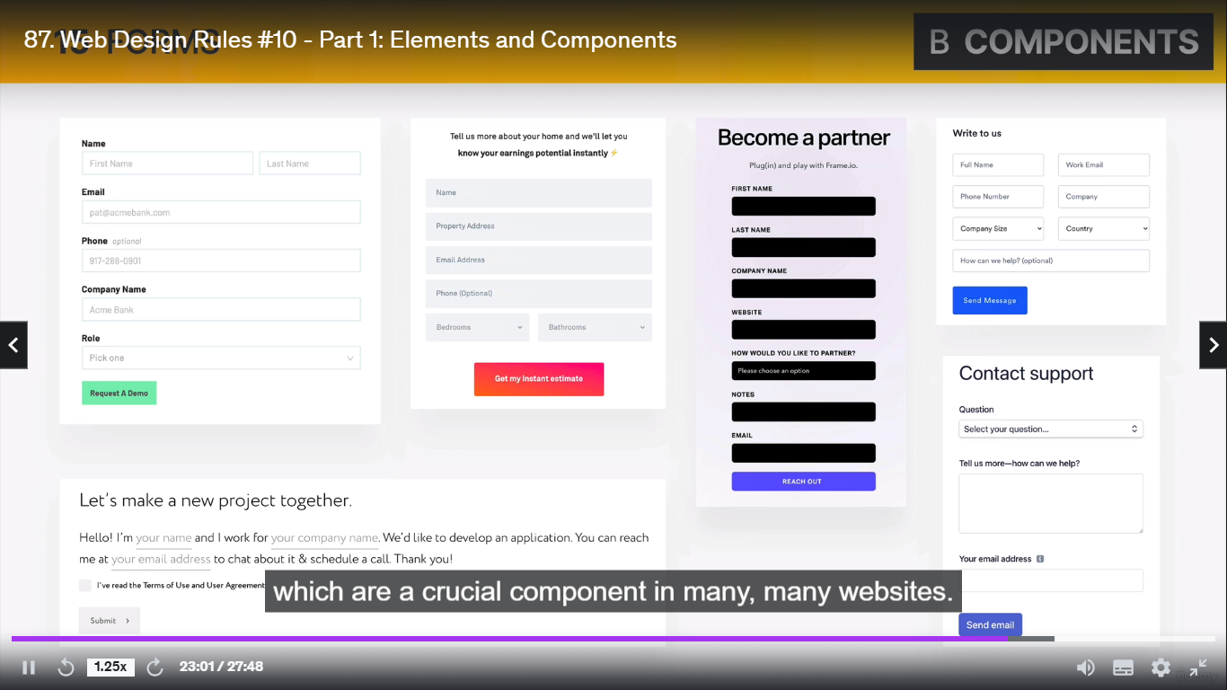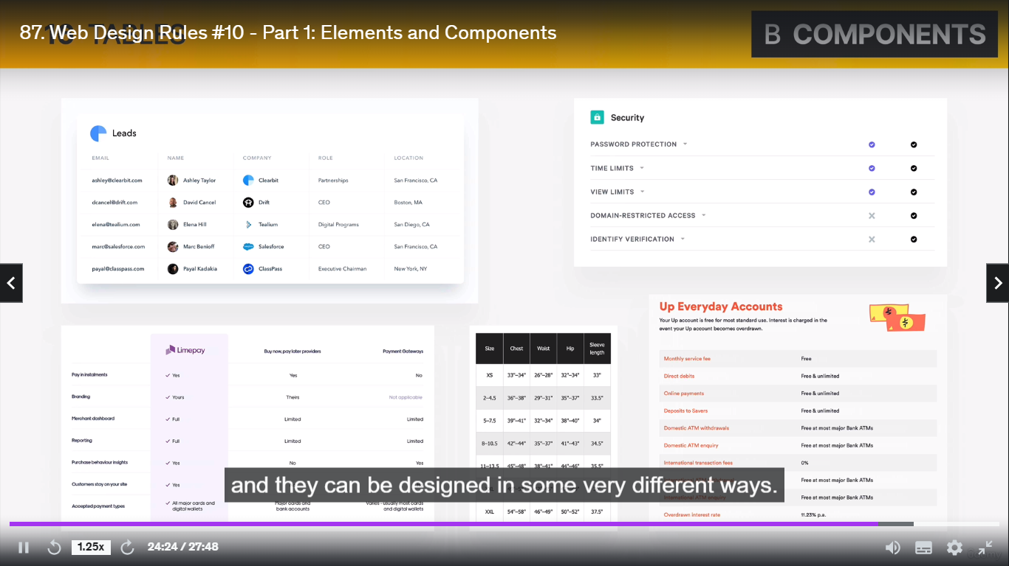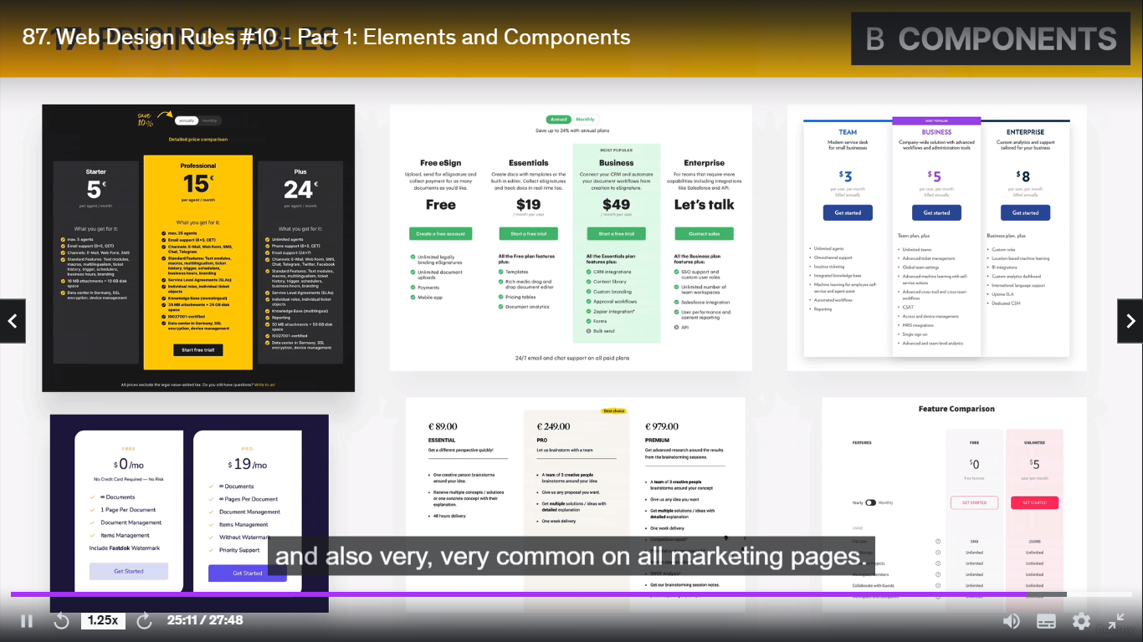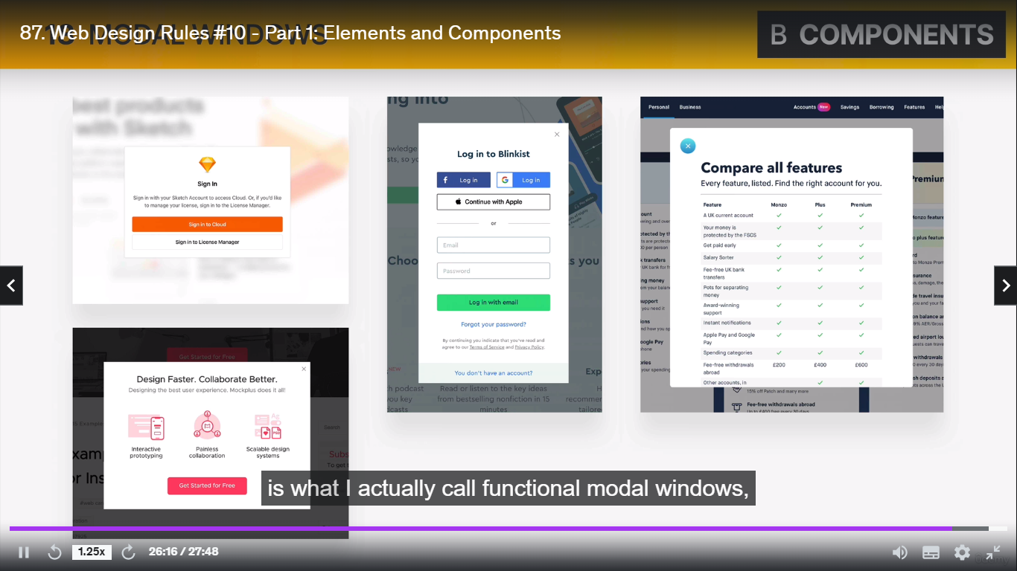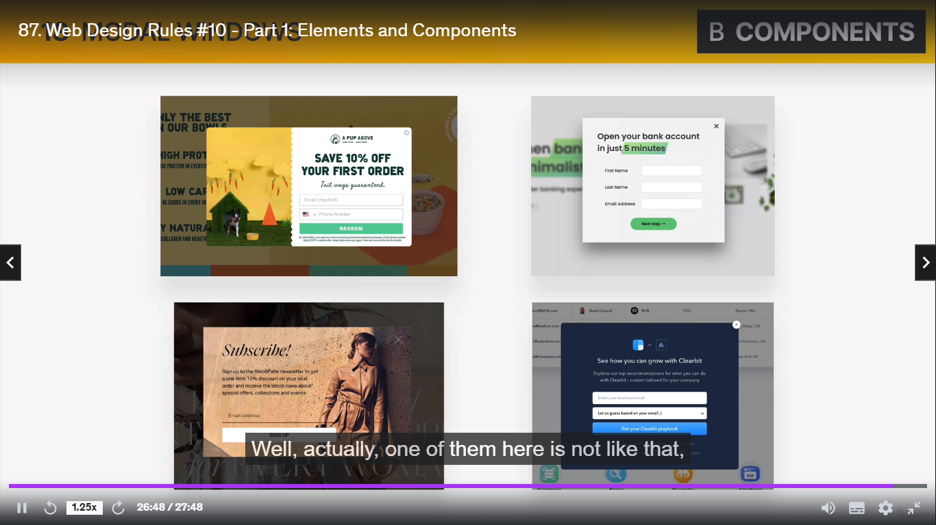

**Accordion:**

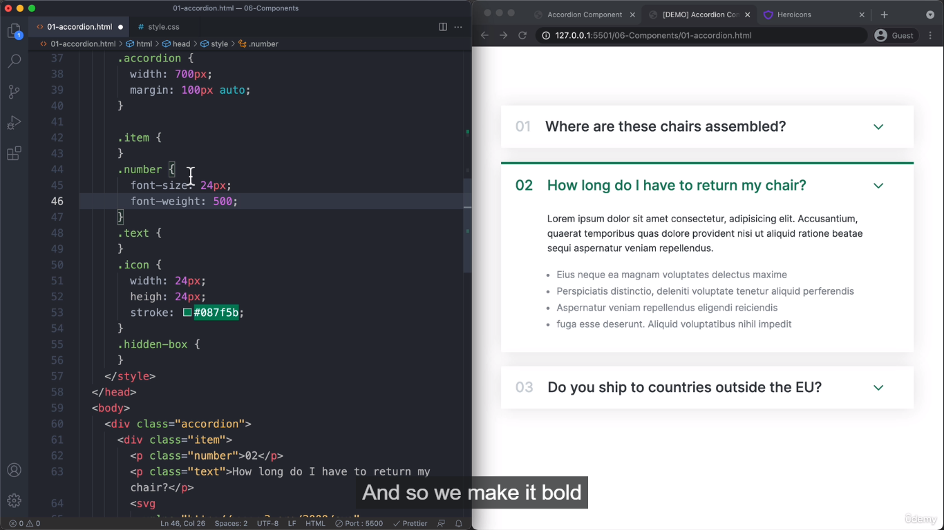

Antha v simple ku colour set panna stroke : th intha mari icons ku ipditha color set pannanum

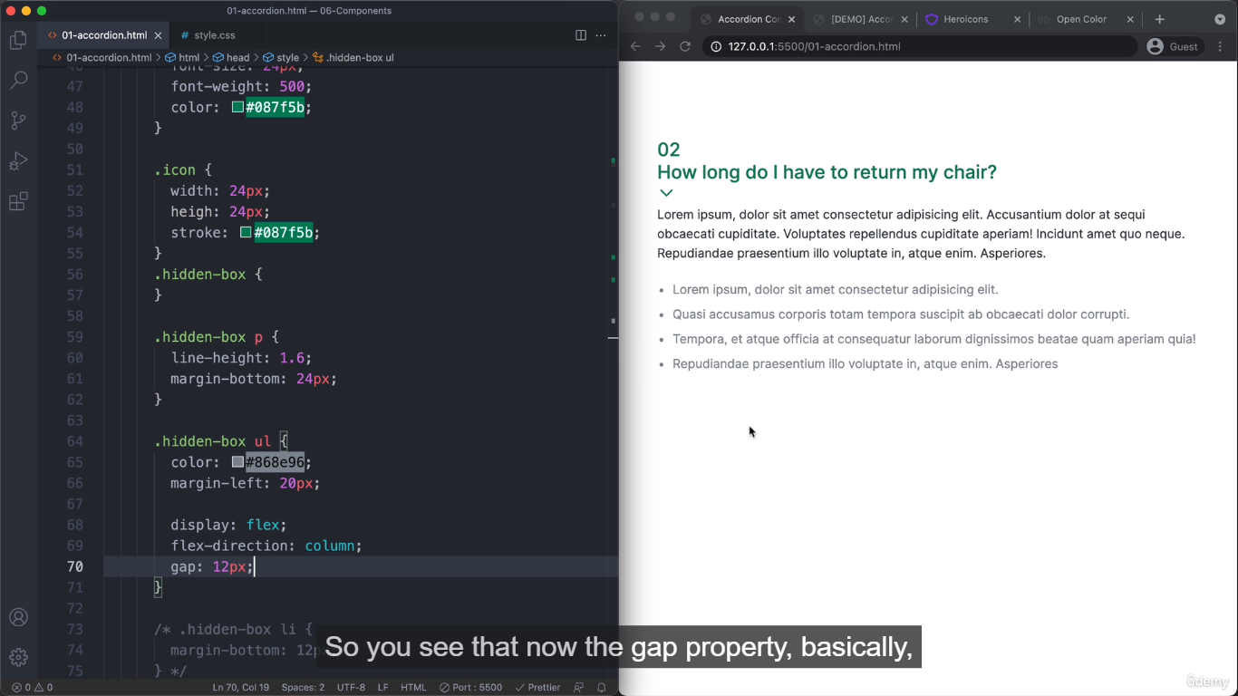

1=> ippo ul kutha color la set pannirukkom athkkulla content list ku innum set pannala so athukku nambo flex use panni work pannikklam

2=> display:flex;

Flex-direction column na antha ul kulklathu ellame colom based la set aagirum

Then athukku gap set pannklam

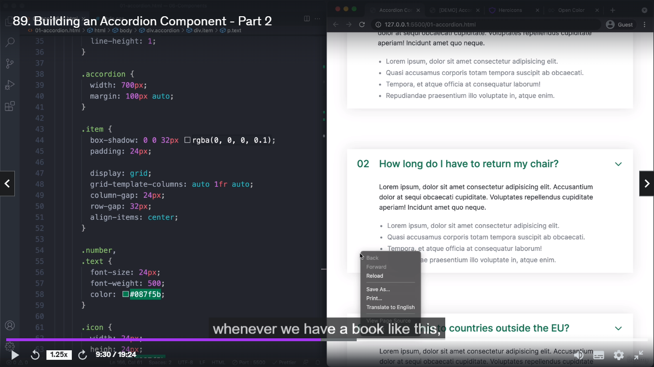

**Web Page Project**

**Clear image download --- unplash.com**

**Free human images --- UI faces**

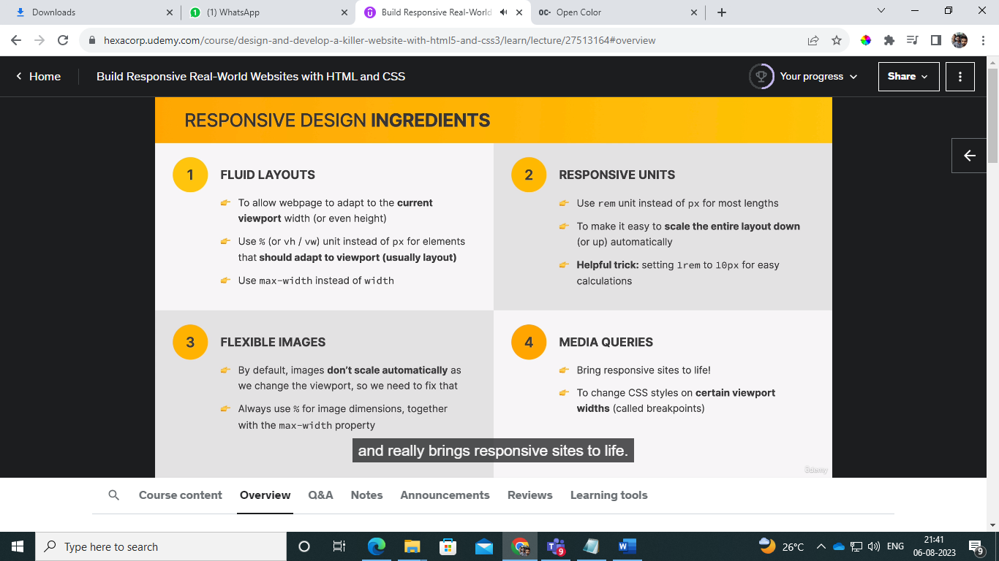

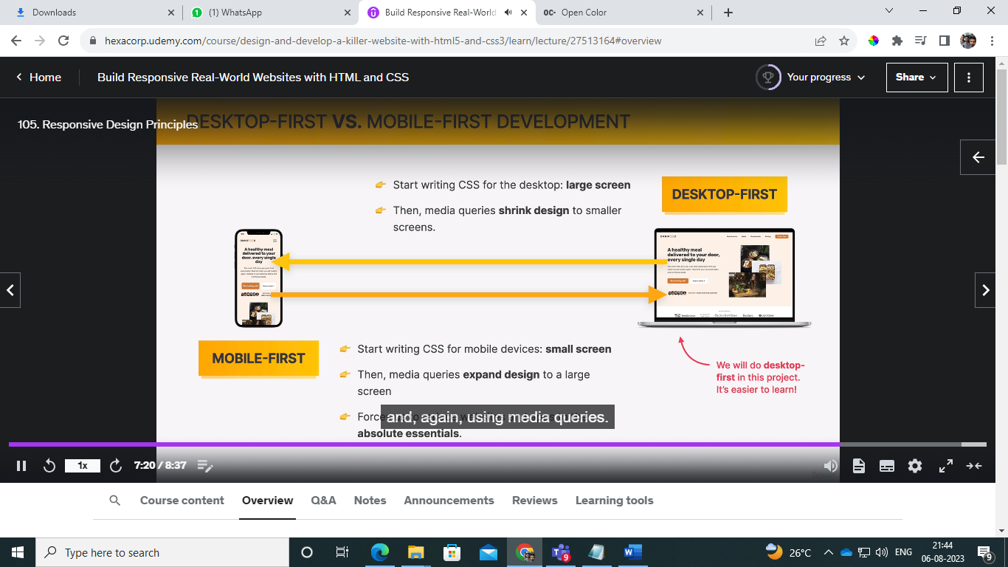

**Max-width: important**

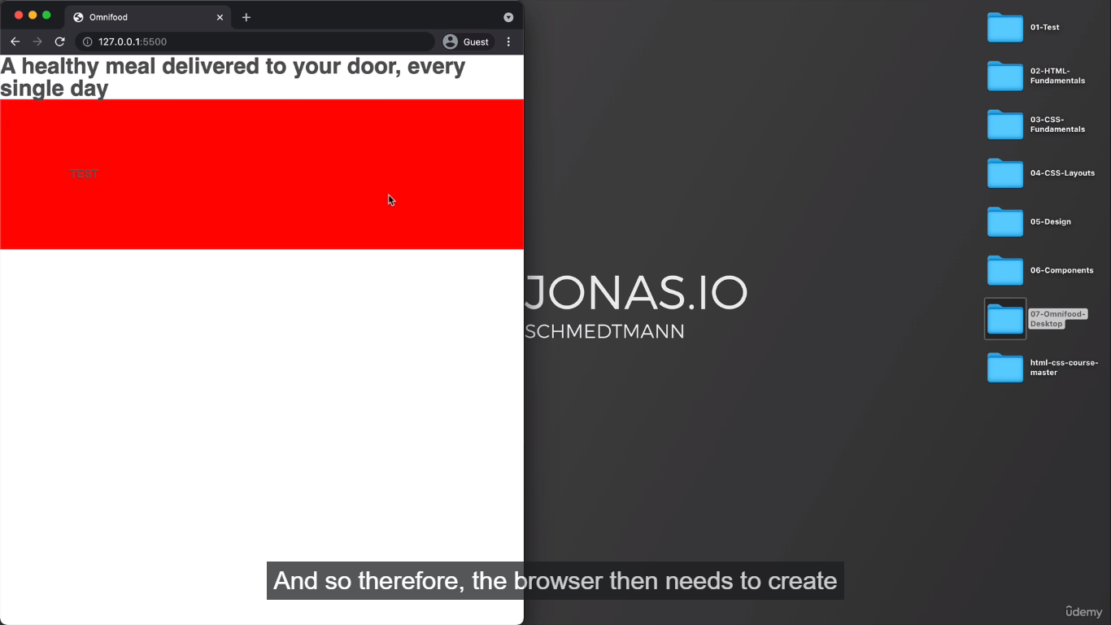

**Width ku 1000px kudutha screen kami pannalum x axis scroll tha aagum antha div kammiyaagathu**

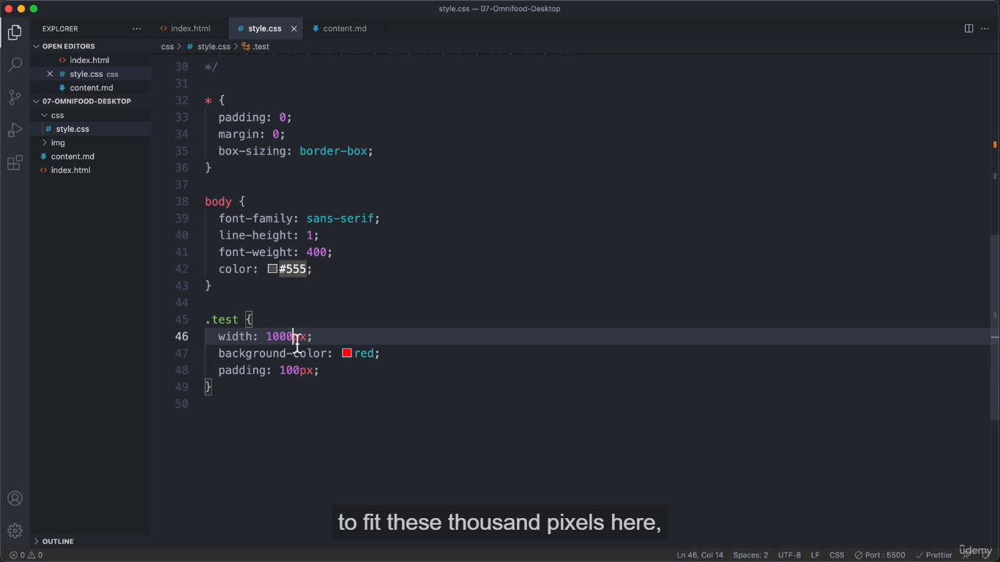

**Rem – root element of font sizw 1 rem –16px la calculate aagikkum**

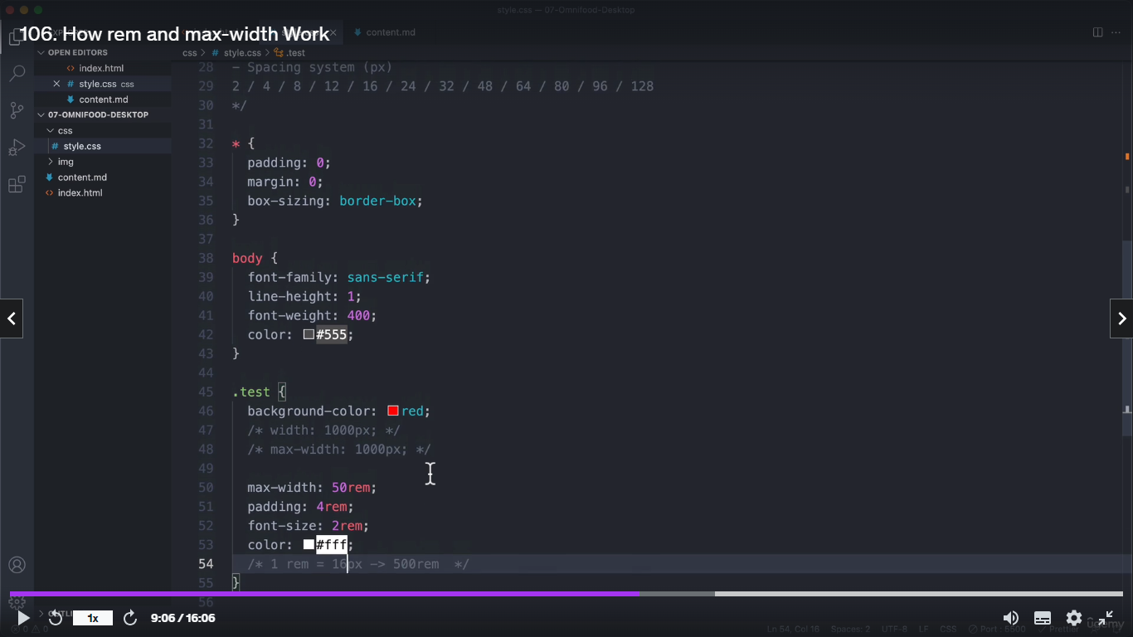

**Rem calculations**

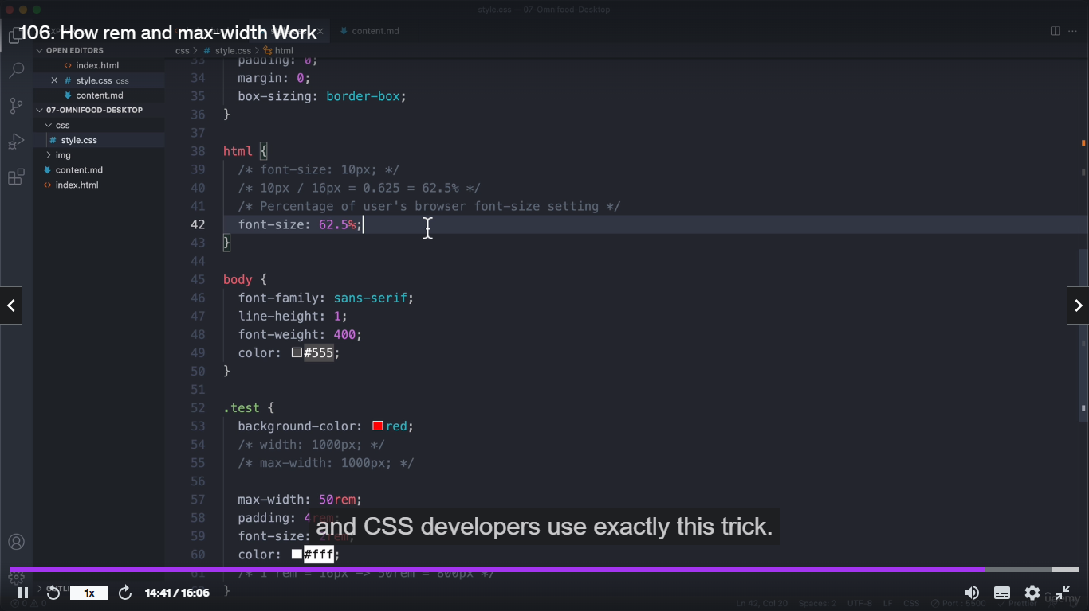

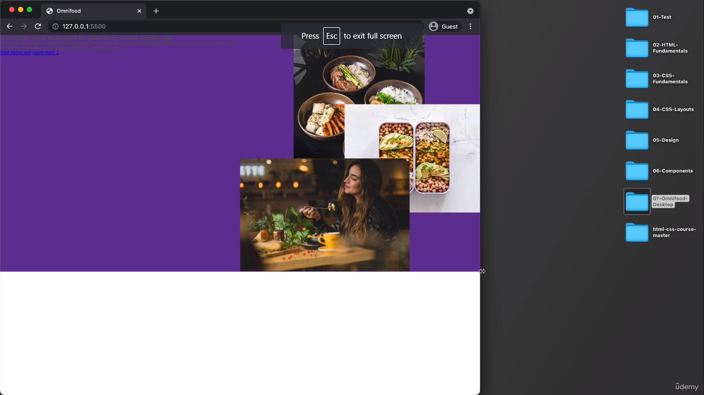

**Ithukkana code img 100% kudutha parant kulla 100% irukkum athum max width 130rem na=🡺1300px so ethukkume px use pannakoodathu em use pannikklam**

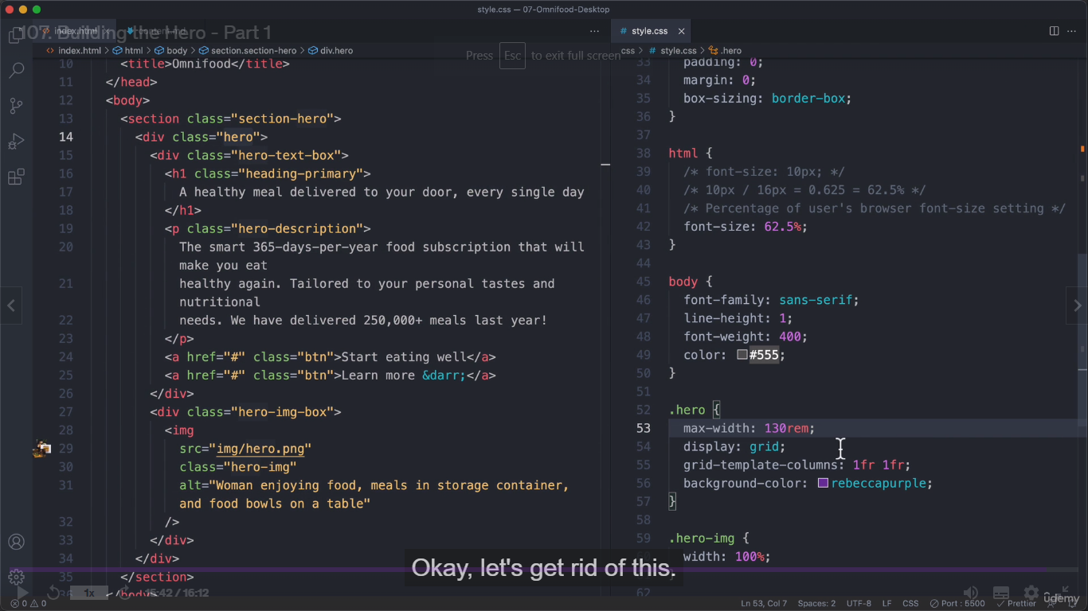

**Margin-top: 0 , auto ;**

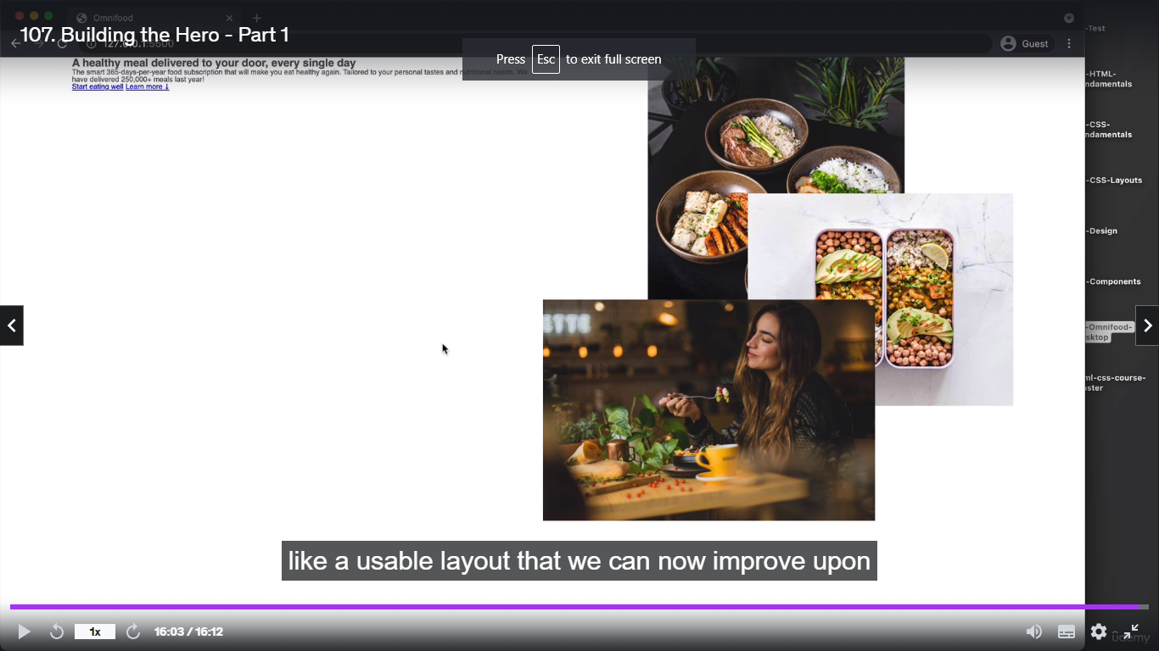

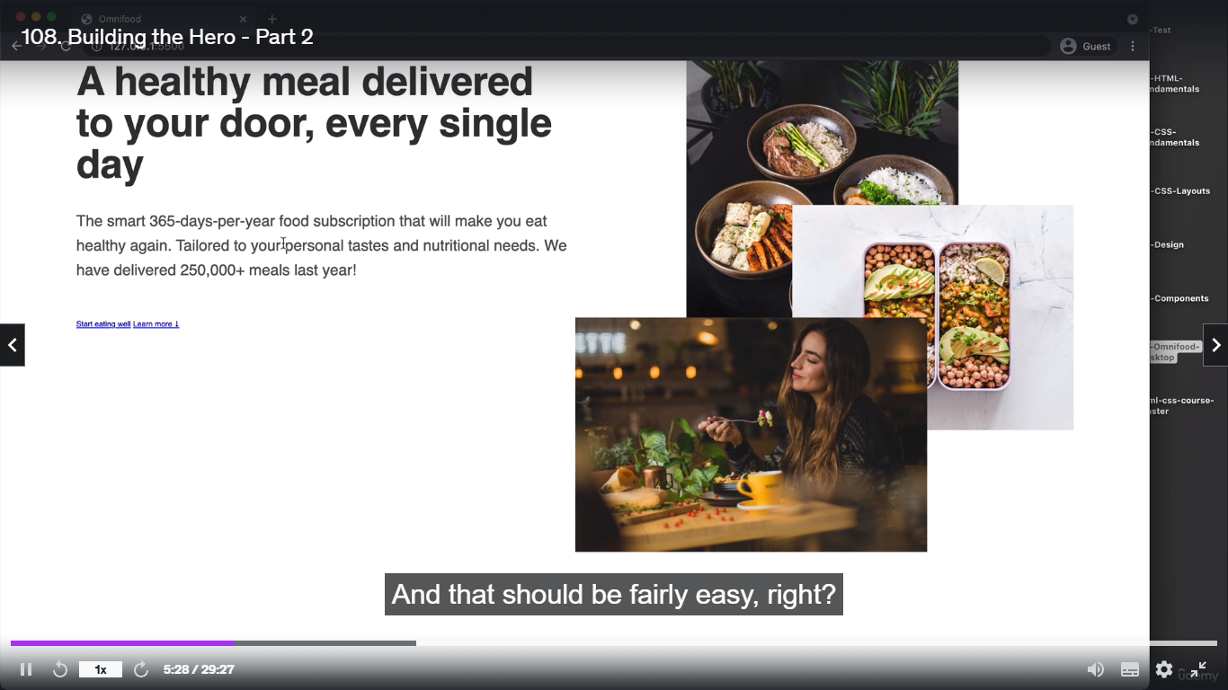

**Ithoda code :**

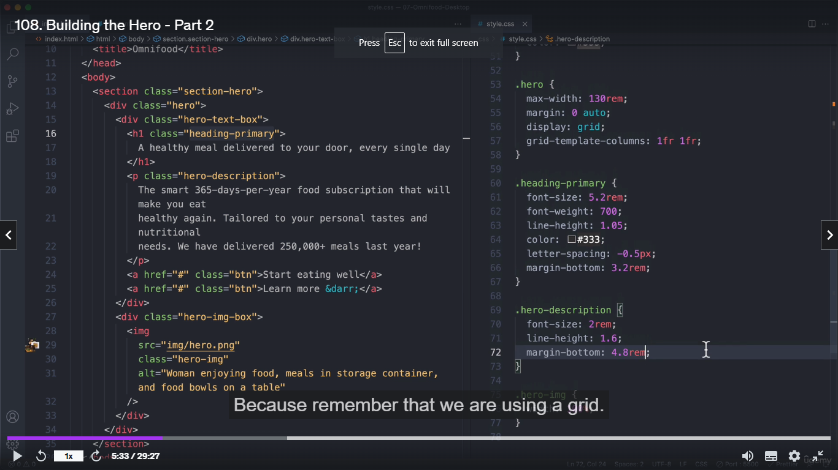

**Ippo ethu shadow newva edukkanumna tint and shade generator irukkum athula namba copy panna color past panna varum**

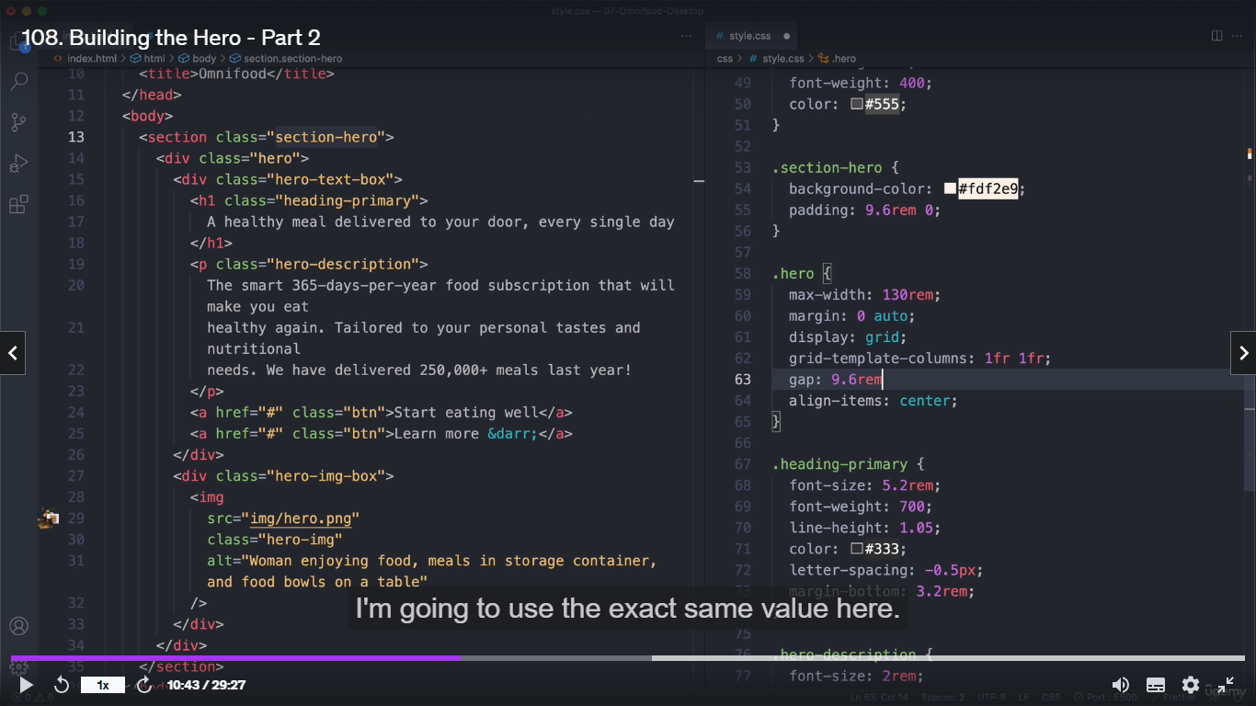**output:**

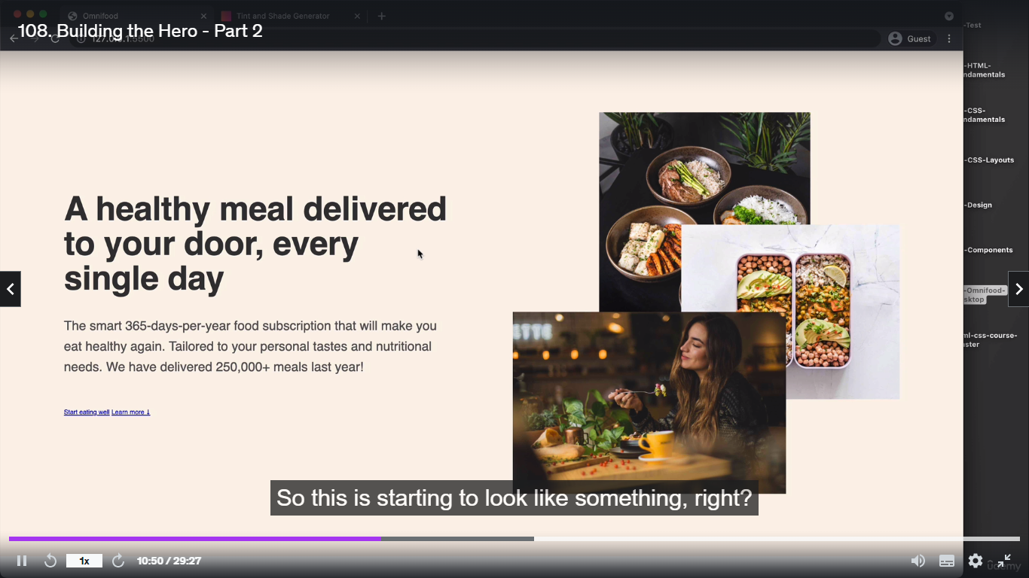

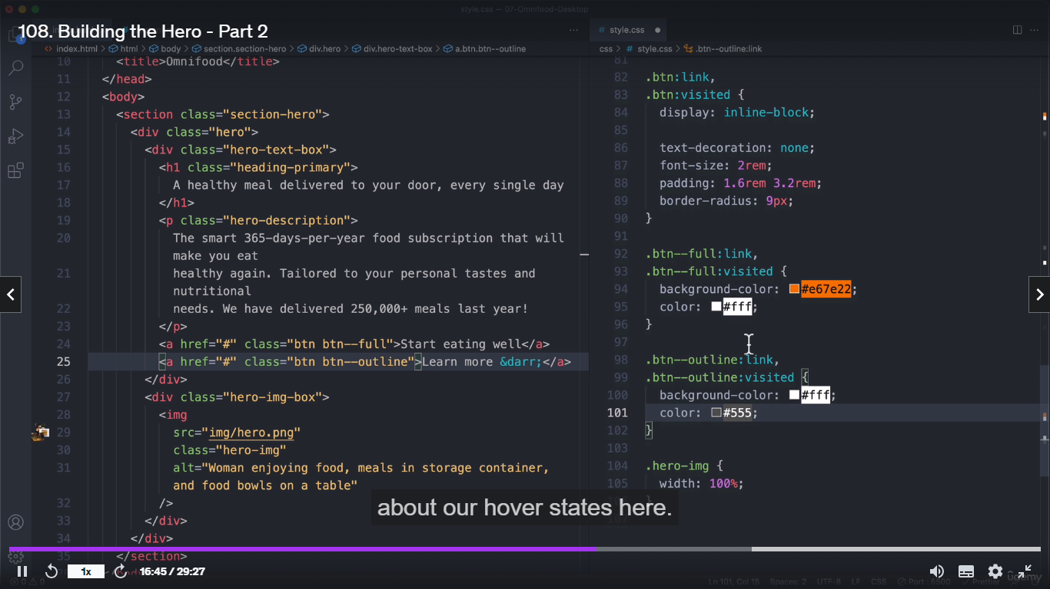

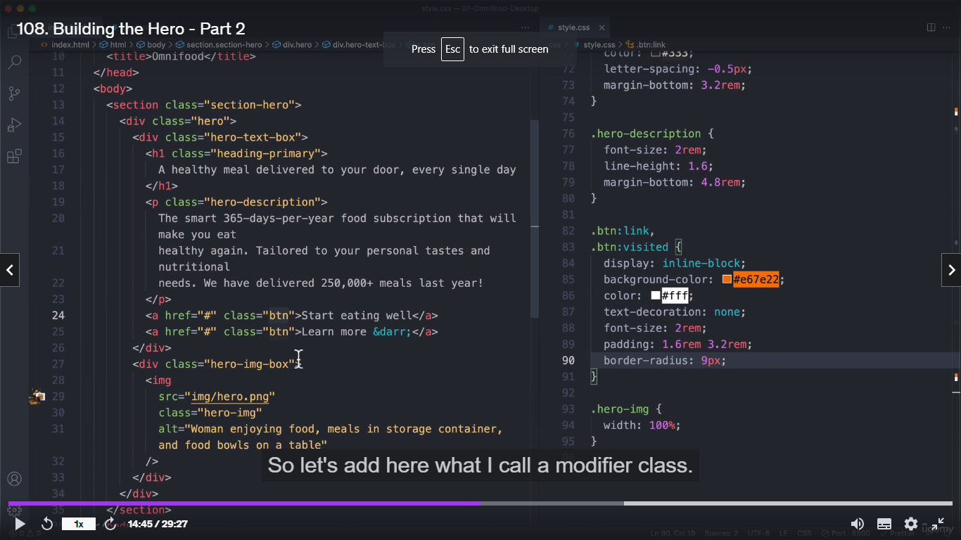

**Output:**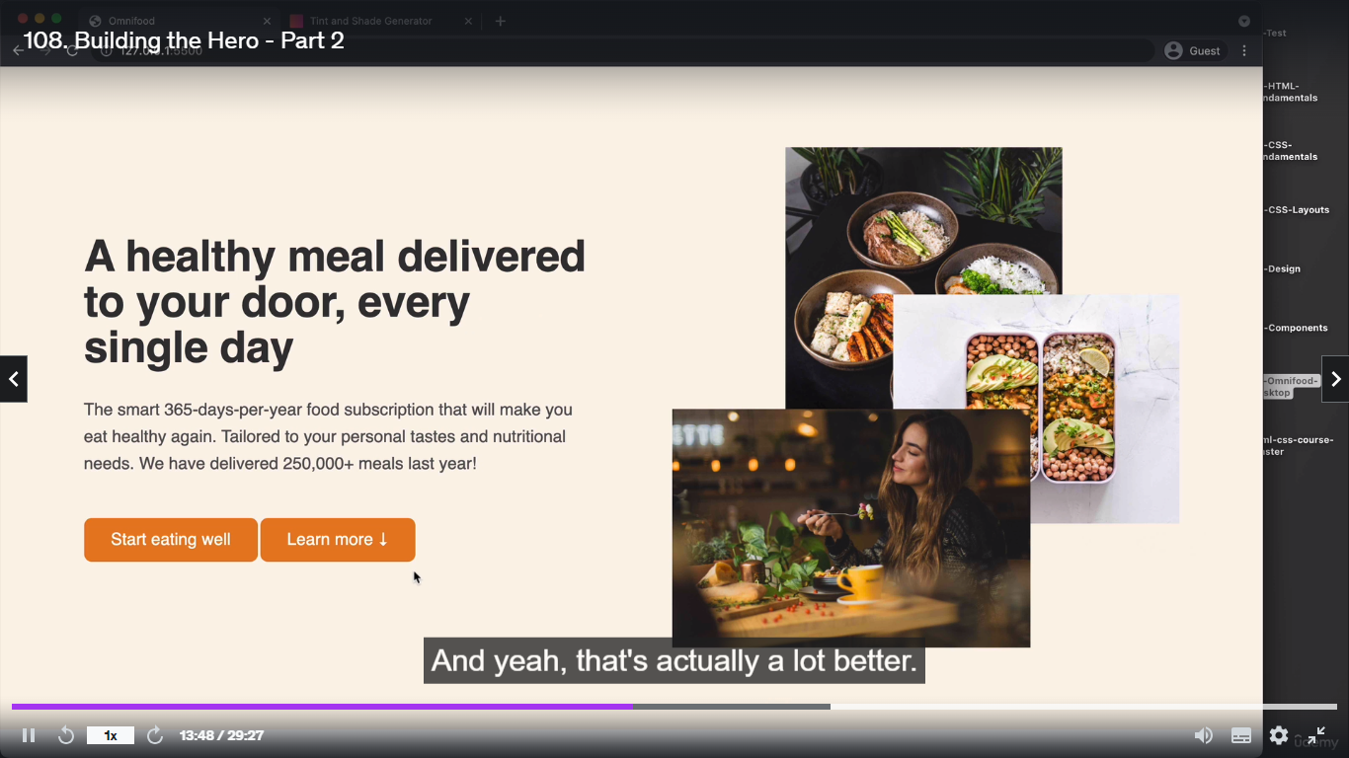

**Ippo our btn set panntu athukku border kuduthomna hover panrappa antha btn inside la irukka contentlam konjam jump aagum atha solve**

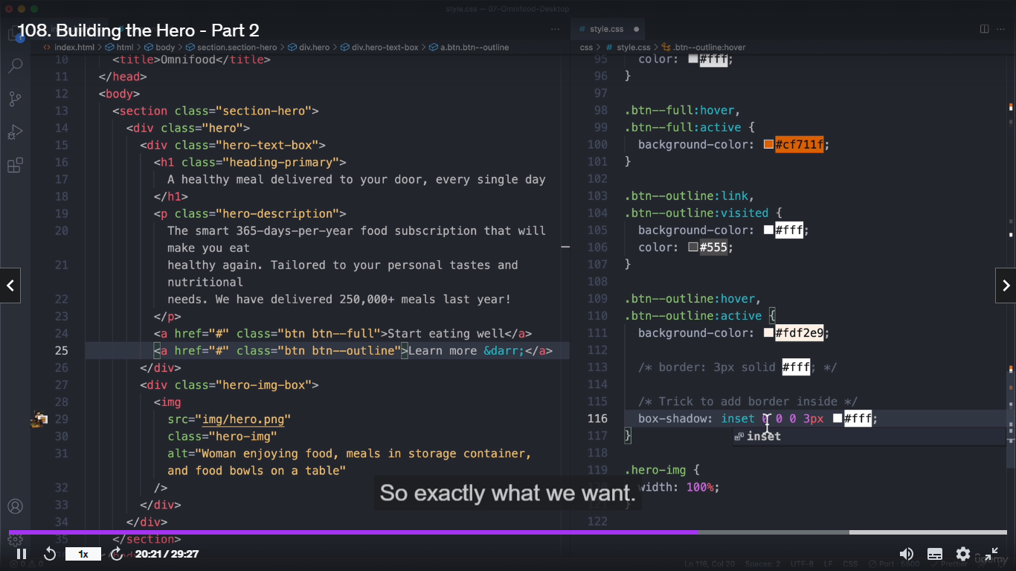

**Box shadow property used – inside the btn**

**Ippo our btn ku animation kudukklam**

**Transition: bg-color 1s;**

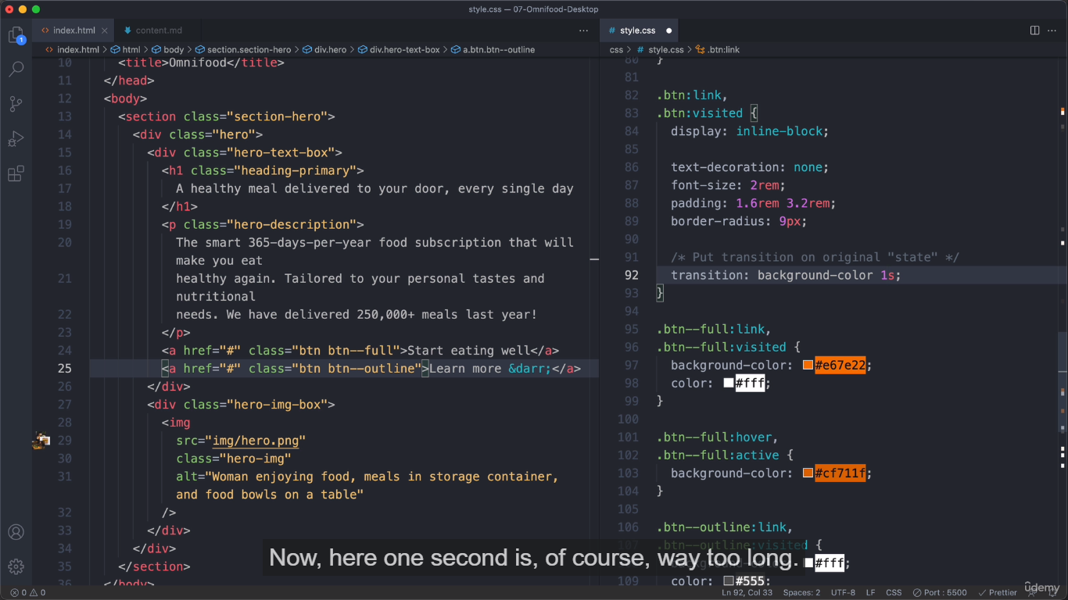

**Before the screen :**

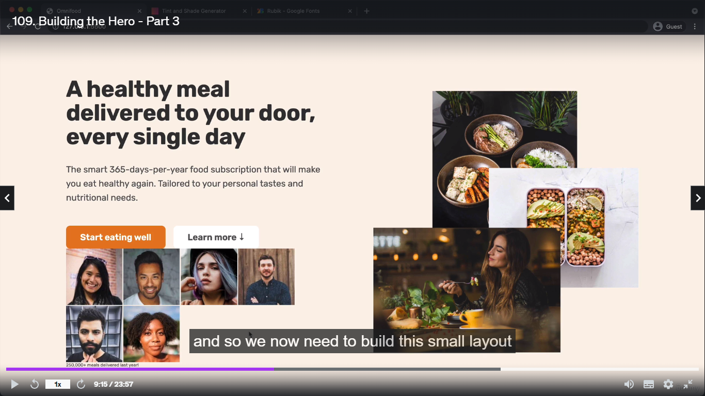

**Code:** 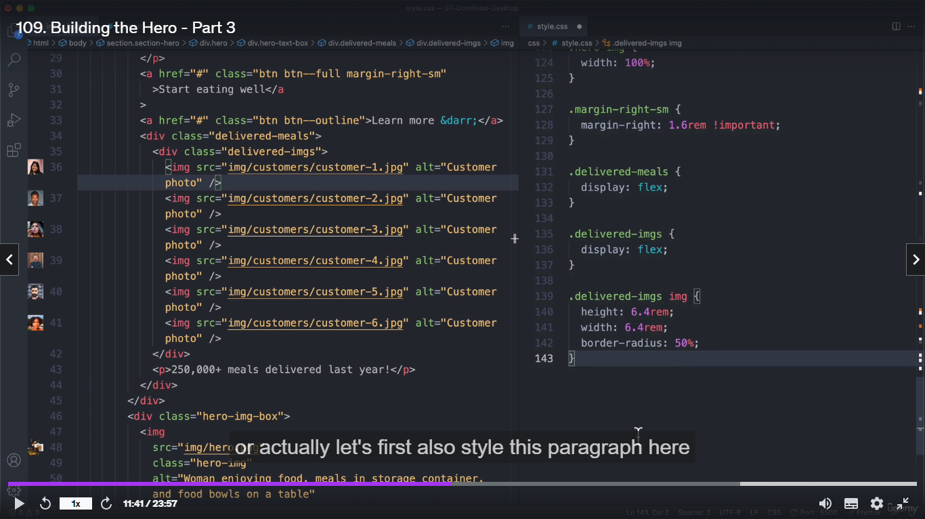

**o/p:**

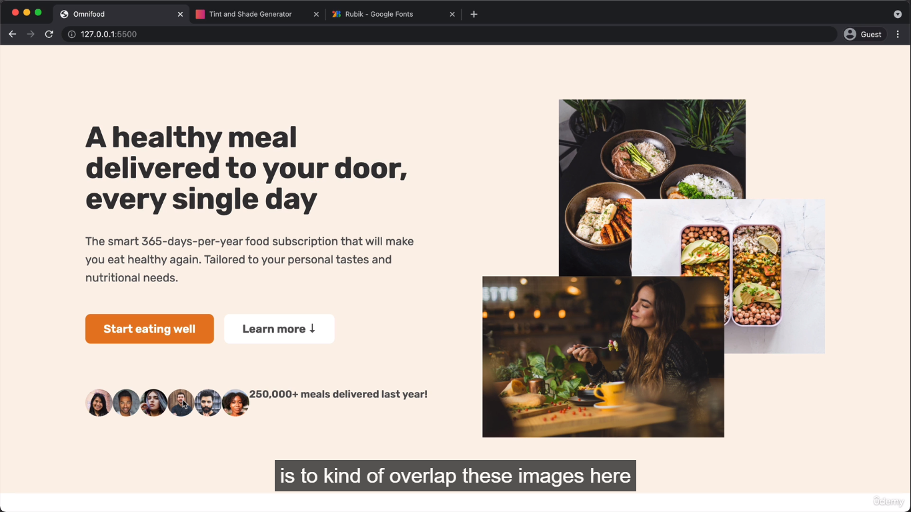

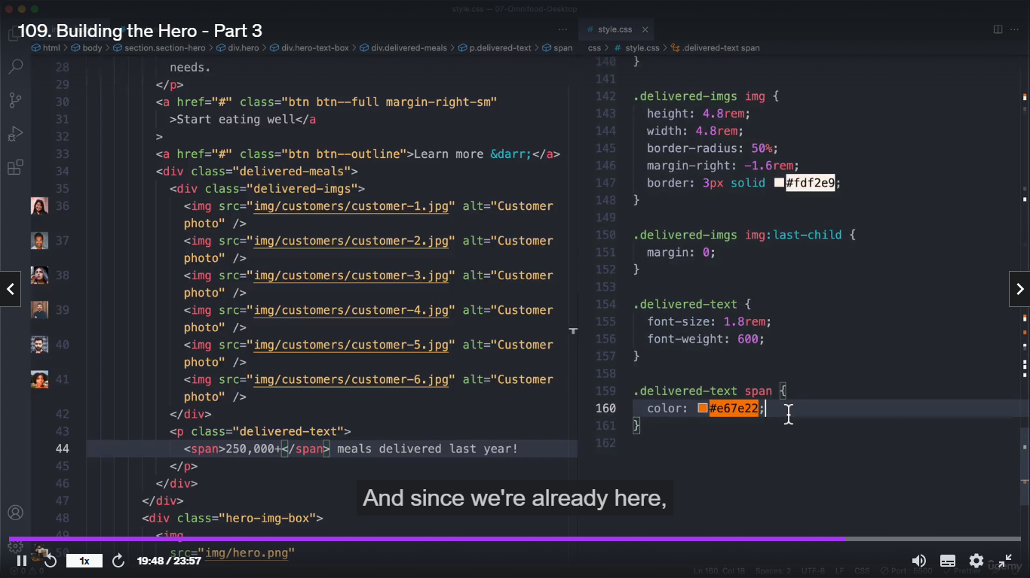

**o/p:**

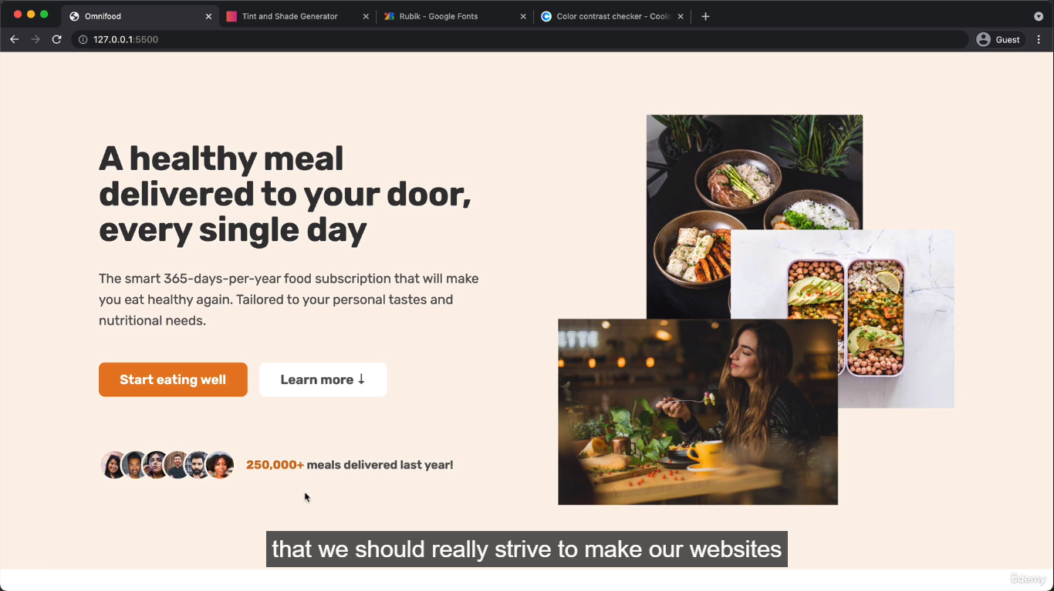

**Header:**

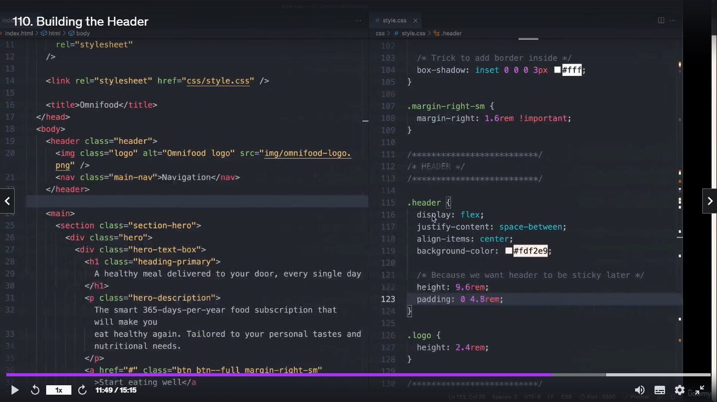

**o/p:**

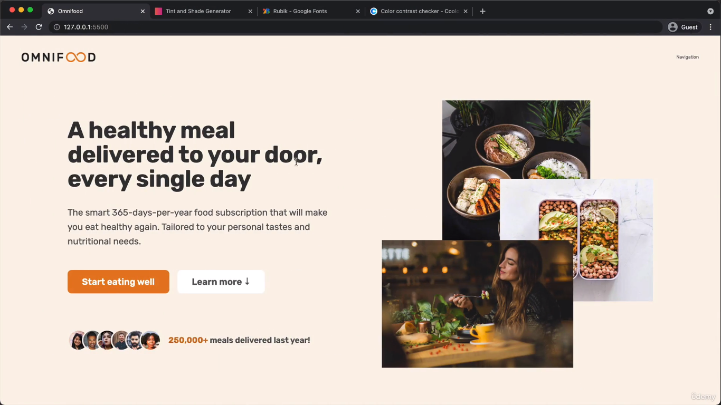

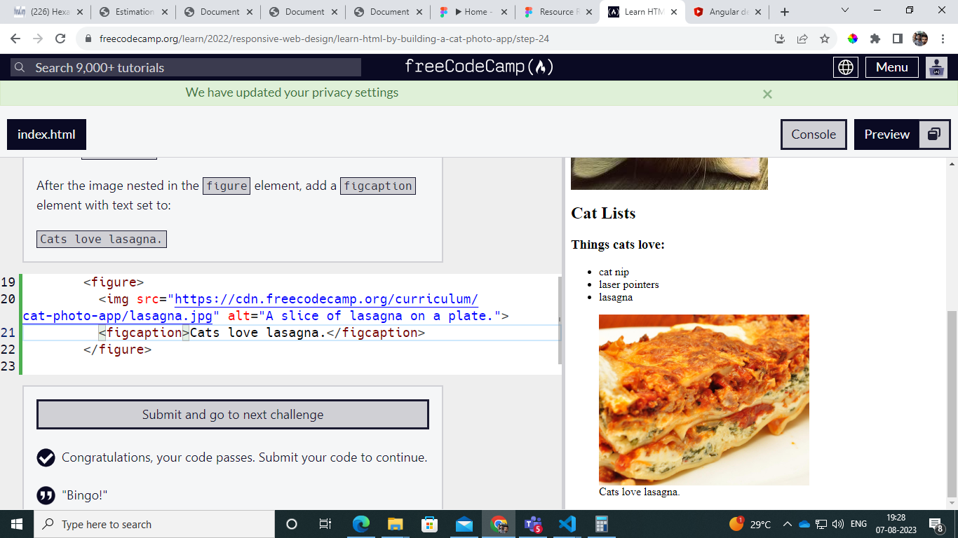

**Img kullaye keela caption podanum figcaption podanum**

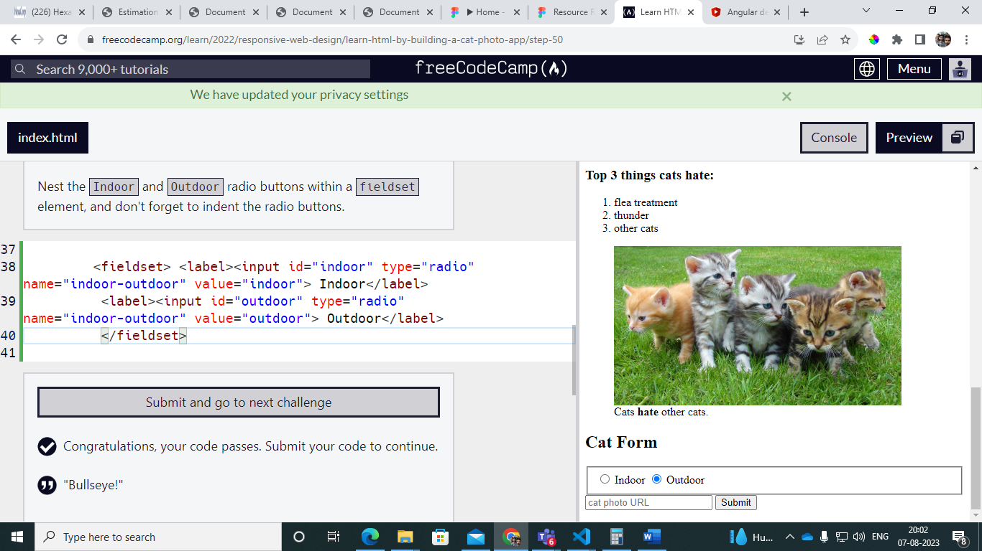

**Fieldset element line block create panrathu**

**Nav bar set panrathu :**

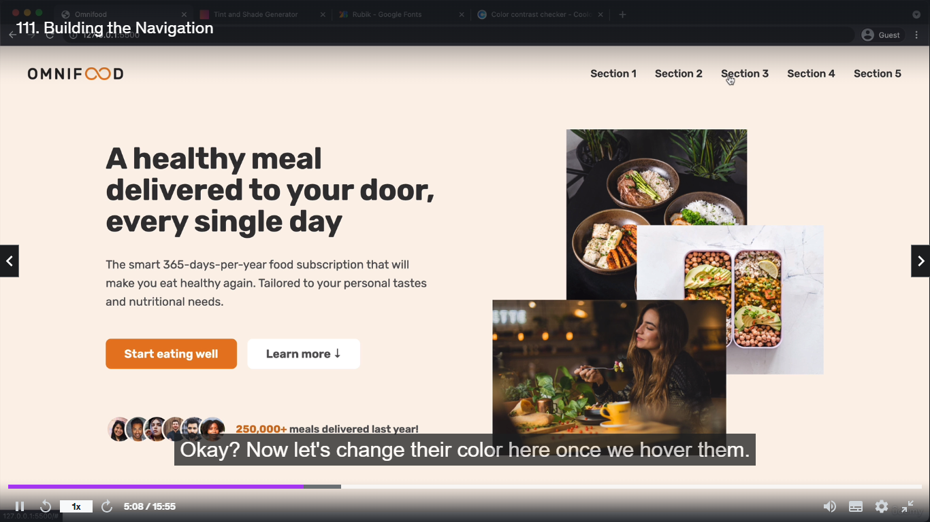

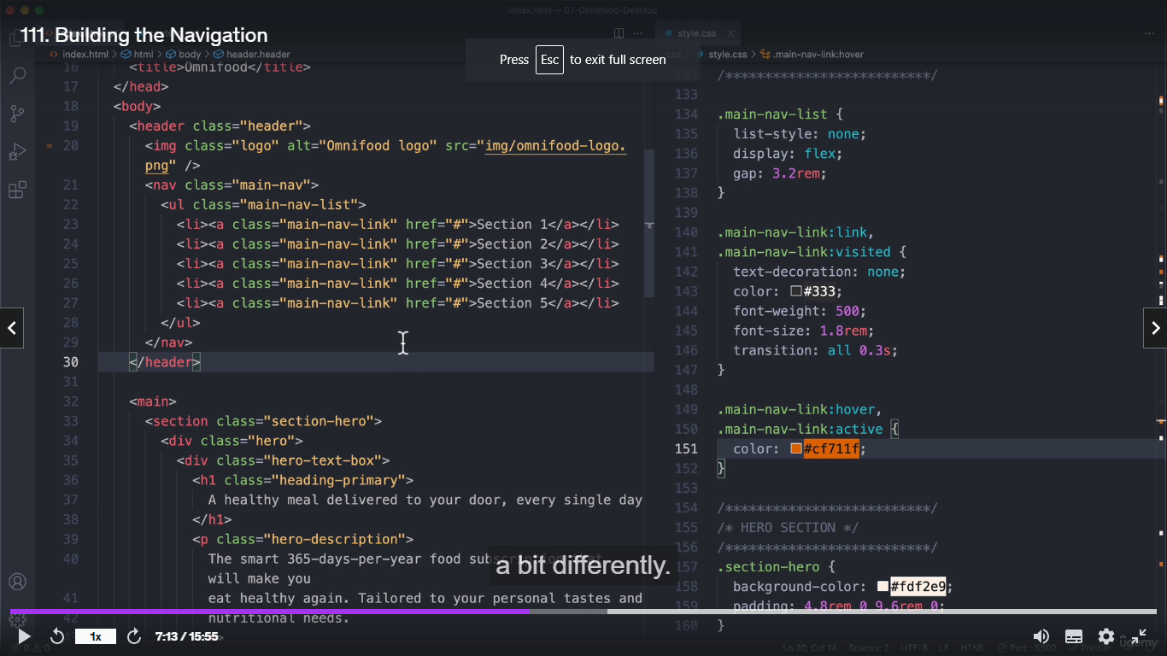

**Grid:**

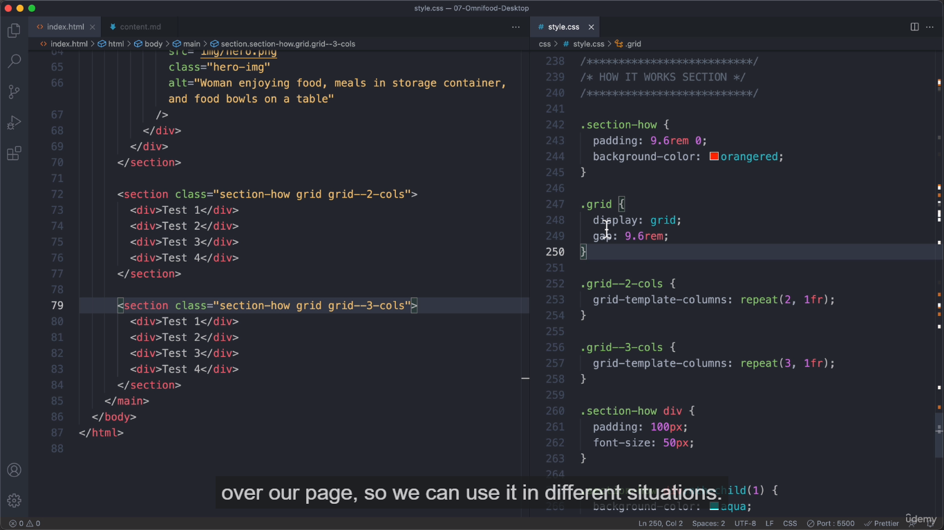

**Left side our content and right bside our content float illama grid vache pannalam**

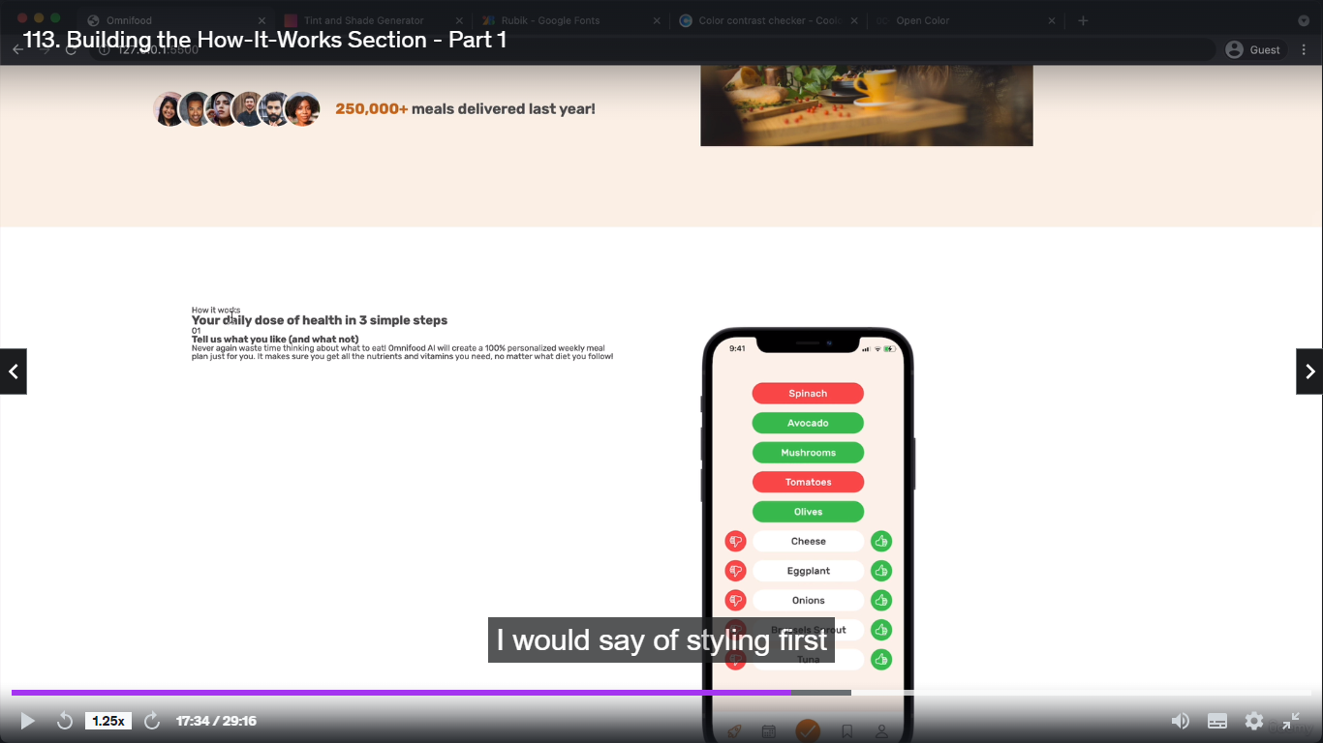

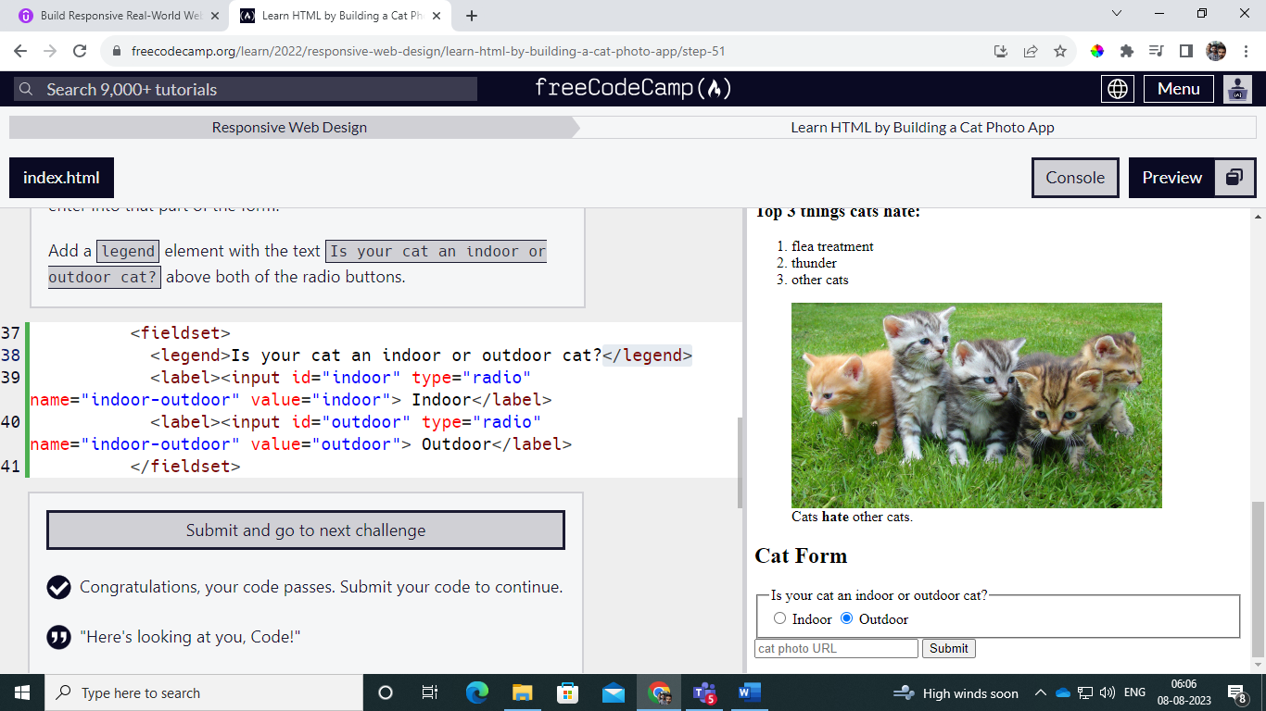

**Legend element caption write panniklam**

**<hr> pottomna code varum**

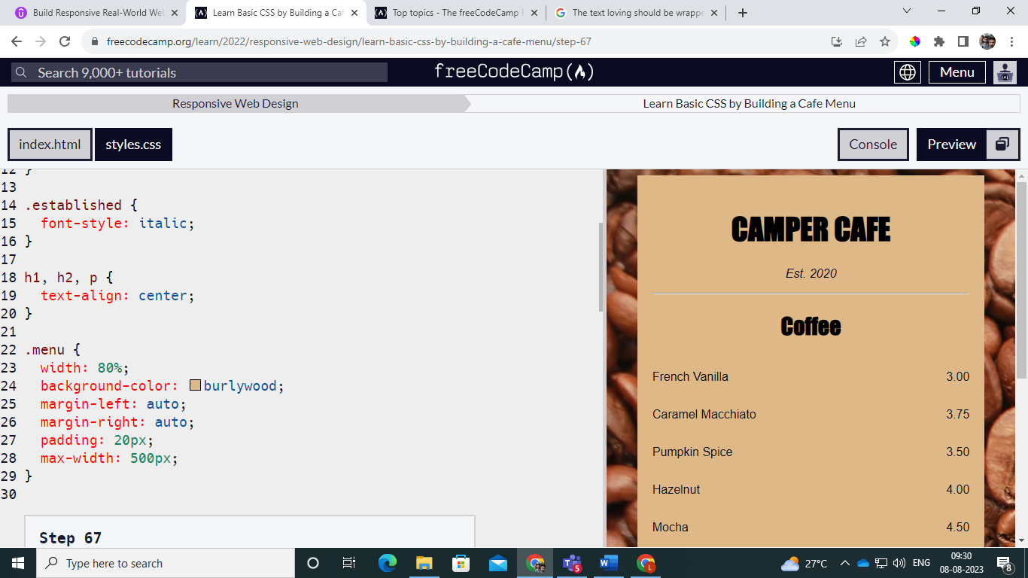

**Flex: one idomentional linelaye display aagirum**

The flex-wrap property determines how your flex items behave when the flex container is too small. Setting it to wrap will allow the items to wrap to the next row or column. nowrap (default) will prevent your items from wrapping and shrink them if needed.

Flex-direction =🡺 row one, coloum

.gallery {

  display: flex;

  flex-direction: row;

  flex-wrap:wrap;

}